 | 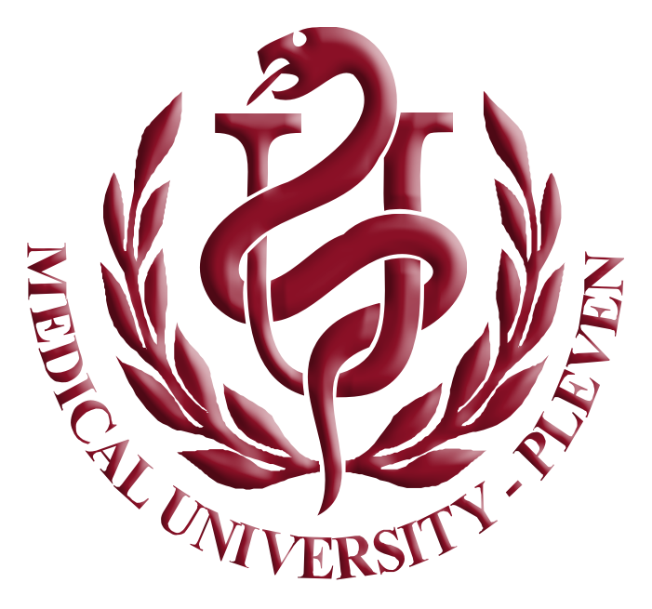 | MEDICAL UNIVERSITY - PLEVEN  1, “Sv. Kliment Ohridski”str.  5800 Pleven, Bulgaria  Tel.: +359 64 884 292  Email: iro@mu-pleven.bg

ERASMUS PROGRAMME
STAFF TRAINING
Work plan

For the staff training grants, the selection of the HEI's staff will be done by the sending institution on the basis of a "work plan" submitted by the applicant and endorsed by both the sending institution and the host institution/enterprise.

Information about the home institution and the host institution or enterprise:
- Name of the staff member
- Name of the home institution (and Erasmus ID code)/department:
- Name of the host institution (and Erasmus ID code)/department or enterprise/department (and country of host enterprise):
- Name of the contact person from the sending institution:
- Name of the contact person from the receiving institution/enterprise:
- Position of the contact person from the sending institution:
- Position of the contact person from the receiving institution/enterprise:
- Information relating to the sending or hosting Institution/Enterprise:

Duration (days):

Overall aim and objectives of the mobility:

Activities to be carried out and, if possible, the programme for the period

Expected results

APPLICANT
Date and signature:

HOME INSTITUTION | HOST INSTITUTION/ENTERPRISE
We confirm that this proposed work programme is approved | We confirm that this proposed work programme is approved
Date: | Date:
Signature of Head of Department/Director/  Dean of Faculty/Institute: | Signature:
Stamp: | Stamp:

