MEDICAL UNIVERSITY – PLEVEN

FACULTY OF MEDICINE

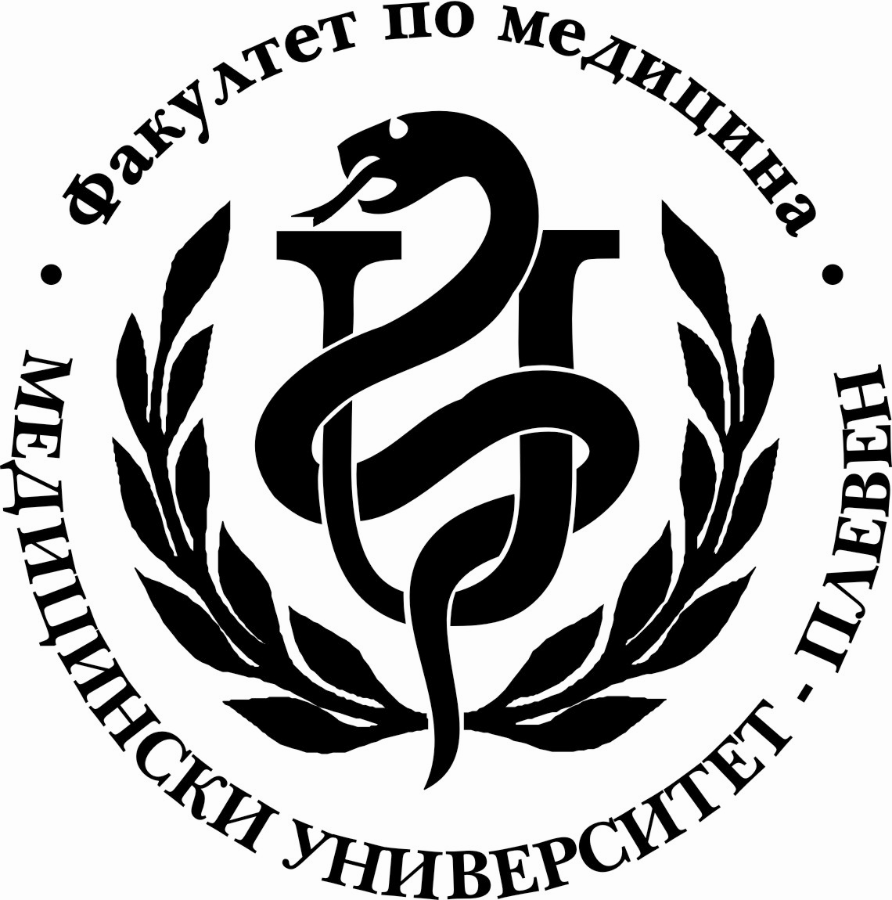

D I A R Y

COMPULSORY SUMMER PRACTICE

OF …………….……………….........……………… STUDENT OF IIITH COURSE, FAC.№ …...…
MEDICAL UNIVERSITY – PLEVEN

FACULTY OF MEDICINE

D I A R Y
of compulsory summer practice

of …………….………………….........………………

who completed his third year as a medical student

fac.№ ELE…..… group №……….

Hospital ….………….…....................…….……….....

from…...…....…. to ….…....…. (totally 30 days)

Date | Working days | Activities | Signature of chief nurse
 | 1
 | 2
 | 3
 | 4
 | 5
 | 6
 | 7
 | 8
 | 9
 | 10
 | 11
 | 12
 | 13
 | 14
 | 15
 | 16
 | 17
 | 18
 | 19
 | 20
 | 21
 | 22
 | 23
 | 24
 | 25
 | 26
 | 27
 | 28
 | 29
 | 30

Student’s grade is: Very good; Satisfactory; Not satisfactory /underline the correct grade/

Head of medical centre:……………………………………………….
/signature/seal//

M E D I C A L U N I V E R S I T Y – P L E V E N

F A C U L T Y O F M E D I C I N E

PROGRAMME
OF COMPULSORY SUMMER PRACTICE ACTIVITIES OF STUDENTS IN MEDICINE AFTER
COMPLETED 6TH SEMESTER

TYPE OF ACTIVITIES

І. INTERNAL DISEASES CLINIC – DURATION OF PRACTICE 15 DAYS
- Sanitary preparation of a newly admitted patient – bath, dressing, putting in bed, diagnosing of parasites and prophylaxis. Laying of patient’s bed in the Intensive care department, the bed of a small child and a suckling. Changing of bedding of a seriously ill patient
- Maintenance of the personal hygiene of a seriously ill patient:
- Morning and evening toilet of a seriously ill patient
- Washing of a patient – mouth, eyes, ears and nose of a seriously ill patient
- Genital care
- Prophylaxis of decubitus
- Feeding of a patient and a seriously ill patient
- Preparing patients and rooms for a visitation
- Physiotherapy: placing of a warming pad; applying a warm and a cold compress, wet rubbing, putting an ice bag, etc.
- Taking care of patients at the Intensive care department
- Taking part in a morning report and in hanging over a duty
- Admittance of a patient at the Internal diseases department
- Measurement and registration of body temperature, pulse rate, blood pressure, breathing, dieresis, body weight and height
- Preparation for an injection – opening of a syringe, drawing the remedy from the ampule and the flacon (ex tempore). Subcutaneous injection under the direct supervision of the nurse
- Taking of a throat secretion and expectoration for examination
- Preparing patients and assisting in pleural, abdominal and lumbar puncture
- Admittance of a casual patient
- Taking part in oxygen administration
- Taking part in therapeutic gymnastics and rehabilitation
- Intramuscle and intravenous injections and inserting of an angiocatheter for intravenous infusion and blood transfusion
- Taking blood samples for haemoculture
- Recording of ECG
- Arranging of and giving medicines to patients. Administration of antibiotics
- Basic laboratory analyses:
Blood: taking of E.S.P., counting of erythrocytes, hemoglobin, leucocytes, determination of hemoglobin
Urine: specific gravity, albumin, sugar, acetone
- Participation at visitations. Attendance of training and scientific meeting
- Measuring blood pressure
- Taking of functional examinations of the body
- Taking history and physical status under physician’s supervision
- Taking part in writing in patient’s book

ІІ. SURGERY CLINIC – DURATION 15 DAYS

- Sanitary preparation of a newly admitted patient – bath, dressing, putting in bed, diagnosing of parasites and prophylaxis. Laying of a patient’s bed in the surgery department, a patient’s bed in the Intensive care department, the bed of a small child and a suckling. Changing of bedding of a seriously ill patient.
- Maintenance of the personal hygiene of a seriously ill patient:
  - Morning and evening toilet of a seriously ill patient
  - Washing of a patient – mouth, eyes, ears and nose of a seriously ill patient
  - Genital care
  - Prophylaxis of decubitus
3. Preliminary treatment of used instruments
4. Enema, giving an enema
5. Taking care of patients in the Intensive care (post operative) unit
6. Taking part in a morning report and in hanging over a duty
7. Taking part in testing blood groups
8. Admittance of a patient in the surgery department
9. Preparation for an injection – opening of a syringe, drawing the remedy from the ampule and the flacon (ex tеmpore). Subcutaneous injection under the direct supervision of the nurse
10. Getting acquainted with the basic surgery instruments
11. Taking of wound secretion for examination; rectal and faecal culture
12. Preparing patients and assisting in pleural, abdominal and lumbar puncture
13. Admittance of a casual patient
14. Taking part in oxygen administration
15. Intramuscle and intravenous injections and inserting of an angiocatheter for intravenous infusion and blood transfusion
16. Taking blood samples for haemoculture
17. Preparing the patient for a check-up
18. Arranging of and giving medicines to patients. Administration of antibiotics
19. Getting acquainted with and filling in the following forms:
- For X-ray examinations
- For blood and urine examinations
- For histological examinations
- For death notice, presence at an autopsy and reporting the results from the autopsy
- Fro microbiological examinations
20. Washing before preparation in operation
- Treatment of wounds
- Bandages
- Participation in plastering and splinting of fractures
- Participation in a stomach lavage

