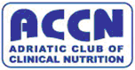

5th ACCN Course in Clinical Nutrition

Pleven, February 19th – 22nd 2009

Adriatic Club of Clinical Nutrition

for DOCTORS AND EDUCATORS

Project No: LLP-LDV-TOI-07-BG-166014

PROGRAMME

Day 1 | THURSDAY,  FEbruary 19th 2009 | Speaker/Tutor
8⁰⁰-10⁰⁰ | Registration of Participants
10⁰⁰-10¹⁵ | Opening of Course
10¹⁵-11⁴⁵ | Modern Concepts of Nutritional Support in Liver Transplantation | Prof. N. Vladov
12⁰⁰-12⁴⁵ | Clinical Nutrition and Metabolism | Prof. R. Komsa-Penkova
13⁰⁰-14⁰⁰ | Lunch
14⁰⁰-14⁴⁵ | Clinical Nutrition and Metabolism
15⁰⁰-16³⁰ | Body Composition. Energy Balance | Prof. R. Komsa-Penkova
16³⁰-17⁰⁰ | Coffee break
17⁰⁰-18³⁰ | Nutrition Assessment | Prof. R.Meyer
19³⁰ | Welcome Party

Day 2 | FRIDAY,  fEBruary 20th 2009 | Speaker/Tutor
08⁰⁰-10⁰⁰ | Nutrition Support and Goals in Perioperative Period | Prof. R.Meyer
10⁰⁰-10³⁰ | Coffee break
10³⁰-12³⁰ | Nutritional Support in Trauma and Burns | Prof. R.Meyer  Dr.M. Panisic
12³⁰-13⁰⁰ | Test
13⁰⁰-14⁰⁰ | Lunch
14⁰⁰-15³⁰ | Enteral Nutrition: Indications and Contraindications, Complications and Monitoring | Prof. Z. Krznaric  Prof. N. Petrov
15³⁰-16⁰⁰ | Coffee break
16⁰⁰-17³⁰ | Nutritional Support in Gastrointestinal Resection | Prof. K. Kucarov
17³⁰-19³⁰ | Social Program
19³⁰ | Dinner Party

Day 3 | SATURDAY,  FEBRUARY 21ST 2009 | Speaker/Tutor
08⁰⁰-10⁰⁰ | Pathogenesis and Treatment of Cancer Cachexia | Prof. A. Laviano
10⁰⁰-10³⁰ | Coffee break
10³⁰-12³⁰ | Nutrition Support during Radiation Treatment and Chemotherapy | Prof. A. Laviano  Prof. R.Meyer
12³⁰-13⁰⁰
13⁰⁰-14⁰⁰ | Test Lunch
14⁰⁰-15³⁰ | Parenteral Nutrition: Indications and Contraindications | Dr.M. Panisic
15³⁰-16⁰⁰ | Coffee break
16⁰⁰-17³⁰ | Parenteral Nutrition: Complications and Monitoring | Prof. N. Petrov
17³⁰-19³⁰ | Social Program
19³⁰ | Dinner

Day 4 | SUNDAY,  FEBRUARY 22ND 2009 | Speaker/Tutor
08⁰⁰-10⁰⁰ | General Principles of Prescription and Management of Nutrition Support in ICU | Prof. N. Petrov  Dr. G. Kekstas
10⁰⁰-10³⁰ | Coffee break
10³⁰-12⁰⁰ | Use of Macronutrients in ICU | Prof. N. Petrov  Dr. G. Kekstas
12⁰⁰-12³⁰ | Test
12³⁰-13⁰⁰ | Certification
13⁰⁰-14⁰⁰ | Lunch

Organize:
Adriatic Club of Clinical Nutrition (ACCN)
Programme „ Leonardo da Vinci„  Project No: LLP-LDV-TOI-07-BG-166014 | 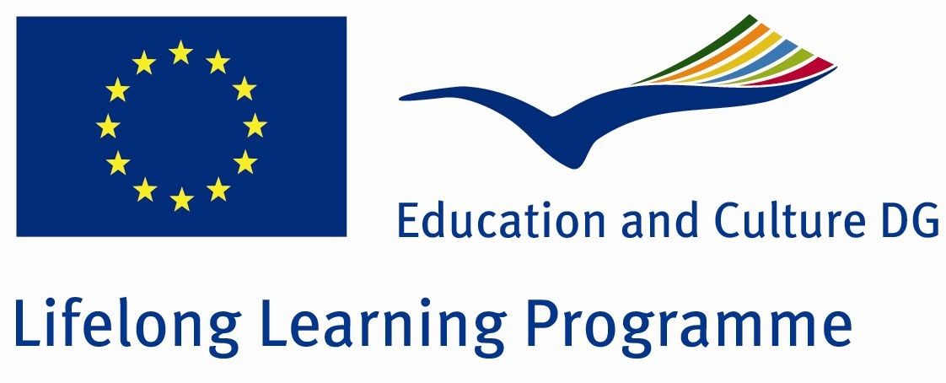
ESPEN | 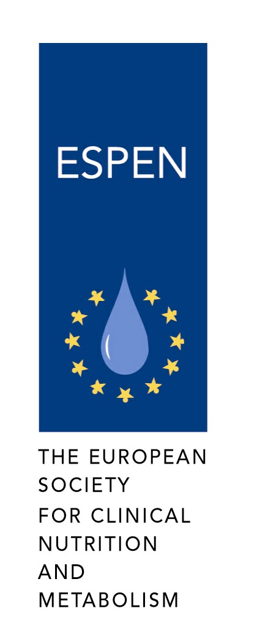
Medical University – Pleven | 
BULSPEN
Alliance „Health in our Hands” | 

Contact details: 884257, 884160 , Email: iro@mu-pleven.bg; rkomsa@gmail.com; anikamenova@gmail.com

