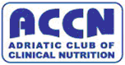

5th ACCN Course in Clinical Nutrition

Adriatic Club of Clinical Nutrition

for doctors / educators

Project No: LLP-LDV-TOI-07-BG-166014

Pleven, February 19th – 22nd 2009

PROGRAMME

Day 1 | THURSDAY,  FEbruary 19th 2009 | Speaker/Tutor
8⁰⁰-10⁰⁰ | Registration of Participants
10⁰⁰-10¹⁵ | Opening of Course
10¹⁵-11⁴⁵ | Modern Concepts of Healthy Nutrition | Prof. B. Popov
12⁰⁰-12⁴⁵ | Clinical Nutrition and Metabolism | Prof. R. Komsa-Penkova
13⁰⁰-14⁰⁰ | Lunch
14⁰⁰-14⁴⁵ | Clinical Nutrition and Metabolism | Prof. R. Komsa-Penkova
15⁰⁰-16³⁰ | Body Coomposition. Energy Balance | Prof. R. Komsa-Penkova
16³⁰-17⁰⁰ | Coffee break
17⁰⁰-18³⁰ | Nutrition Assesment | Prof. R.Meyer
19³⁰ | Welcome Party

Day 2 | FRIDAY,  fEBruary 20th 2009 | Speaker/Tutor
08⁰⁰-10⁰⁰ | Nutrition Support and Goals in Perioperative Period. | Prof. R.Meyer
10⁰⁰-10³⁰ | Coffee break
10³⁰-12³⁰ | Nutritional Support in Trauma and Burns | Prof. R.Meyer  Dr.M. Panisic
12³⁰-13³⁰ | Lunch
13³⁰-14¹⁵ | Test
14¹⁵-14³⁰ | Coffee break
14³⁰-16⁰⁰ | Enteral Nutrition: Indications and Contraindications,Complications and Monitoring | Prof. Z. Krznaric  Prof. N. Petrov
16⁰⁰-19³⁰ | Social Programme
19³⁰ | Dinner Party

Day 3 | SATURDAY,  FEBRUARY 21ST 2009 | Speaker/Tutor
08⁰⁰-10⁰⁰ | Pathogenesis and Treatment of Cancer Cachexia | Prof. A. Laviano
10⁰⁰-10³⁰ | Coffee break
10³⁰-12³⁰ | Nutrition Support during Radiation Treatment and Chemotherapy | Prof. A. Laviano  Prof. R.Meyer
12³⁰-13³⁰ | Lunch
13³⁰-14¹⁵ | Test
14¹⁵-14³⁰ | Coffee break
14³⁰-16⁰⁰ | Parenteral Nutrition: Indications and Contraindications,Complications and Monitoring | Dr.M. Panisic  Prof. N. Petrov
 | Dinner

Day 4 | SUNDAY,  FEBRUARY 22ND 2009 | Speaker/Tutor
08⁰⁰-10⁰⁰ | General Principles of Prescription and Management of Nutrition Support in ICU | Prof. N. Petrov  Dr. G. Kekstas
10⁰⁰-10³⁰ | Coffee break
10³⁰-12⁰⁰ | Use of Macronutritions in ICU | Prof. N. Petrov  Dr. G. Kekstas
12⁰⁰-12³⁰ | Test
12³⁰-13³⁰ | Lunch
13³⁰-14¹⁵ | Closing

Organize:
Adriatic Club of Clinical Nutrition (ACCN)
Programme „ Leonardo da Vinci„  Project No: LLP-LDV-TOI-07-BG-166014 | 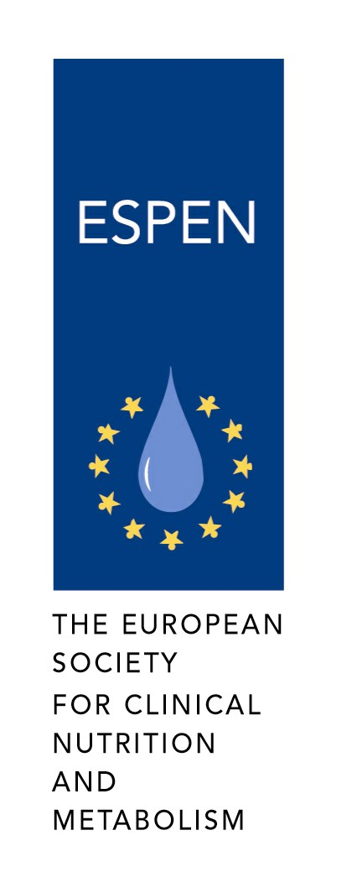  
ESPEN

Medical University – Pleven | 
BULSPEN
Alliance „Health in our Hands” | 

За контакти тел 884257, 884160 , Email: iro@mu-pleven.bg; rkomsa@gmail.com; anikamenova@gmail.com

