Department “Experimental and Clinical Pharmacology,
Dermatology and Venereology”

exercise 6

FOR DISTANCE LEARNING IN DERMATOLOGY AND VENEREOLOGY

FOR MEDICAL STUDENTS
TITLE: „Infestations. Scabies, pediculosis, leishmaniasis”

PREPARED BY Assoc. Prof. I. Yordanova

PLEVEN, 2013

Scabies
Cause - Sarcoptus scabiei, Localization, clinical features, differential diagnosis, treatment (treated all contact persons simultaneously) with solutions of benzoyl benzoate and sulfur 30%, permethrin, children and babies - 10-20%, thorough disinfection of clothes and covers.
Pediculosis
Pediculosis capitis - etiology, localization, clinical presentation, differential diagnosis and treatment.
Pediculosis corporis - etiology, localization, clinical presentation, differential diagnosis and treatment.
Pediculosis pubis - etiology, localization, clinical presentation, differential diagnosis and treatment - benzoyl benzoate solutions. Permethrin or copper oleinat (Cuprol)
Leishmaniasis – disease caused by a protozoan microorganism transmitted by the bite of the sandfly - little insect which spread in tropical and subtropical regions. Clinical spectrum of leishmaniasis varies from self-healing skin wound, mucocutaneous disease with mutilation, to lethal systemic disease. Protozoa are sequestered in the macrophages in the skin, bone marrow,
Andreticuloendothelialsystem.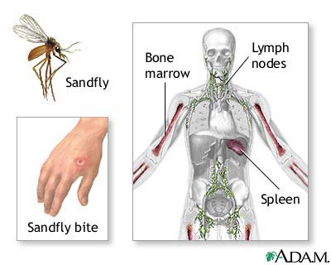 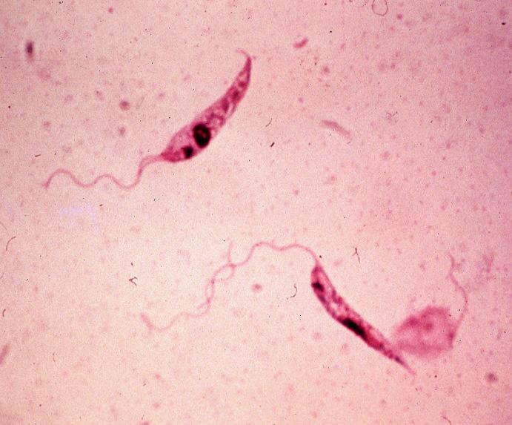

The majority of cases of skin disease were observed in Afghanistan, Algeria, Brazil, Peru, Iran, Iraq, Syria, Saudi Arabia, while most visceral forms of the disease occur in India, Bangladesh, Nepal, Brazil, Sudan.
Treatment - Antifungals - Amphotericin B - 1 mg / kg IV for 20 days
Amebicidal - Aminosidine
Cytokines - Interferon-gamma-1b IV for 28 days

