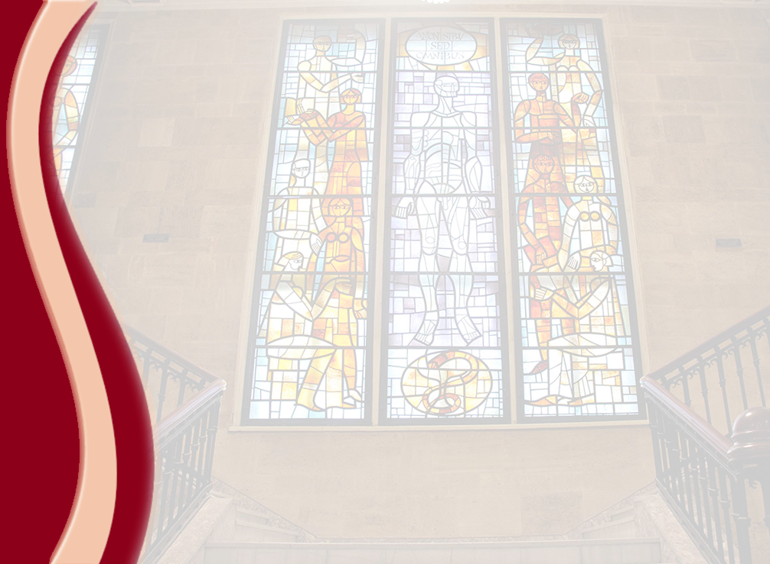

MEDICAL UNIVERSITY - PLEVEN
DISTANCE LEARNING CENTRE

MARGARITA ALEXANDROVA

BIOPHYSICS

lecture course
laboratory assignments

FOR DISTANCE LEARNING

FOR STUDENTS IN MEDICAL UNIVERSITY – PLEVEN

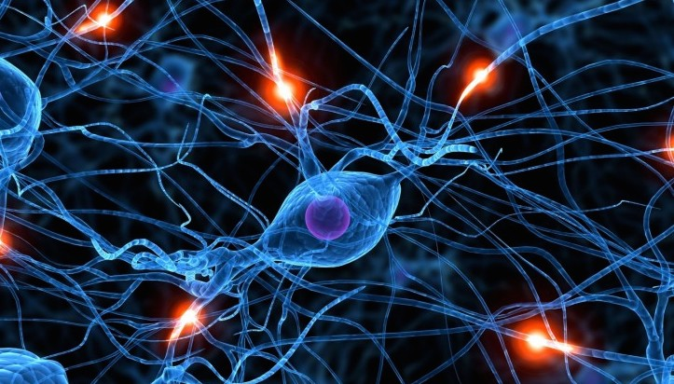

PLEVEN, 2015

