BIOPHYSICS

1. PURPOSE AND OBJECTIVES OF TRAINING
The discipline Biophysics is in the list of compulsory subjects in the Medicine curriculum. It is studied in the second semester of the first year and ends with a semestral exam. One of the main objectives of medical biophysics is the identification of physical and physicochemical parameters for the purposes of objective diagnosing an organism’s functional state. Violation of life processes can be primarily judged by changes in these parameters. Characteristic properties of living cells are the presence of biopotentials, the ability to maintain ionic gradients and carry electric currents, the capability to produce chemiluminescence, etc. The objective of training in Biophysics is to teach students how to apply the concepts and methods of physical science to biological and medical problems. After completing the Biophysics Program students are expected to know the physical laws underlying physiological processes. The program has a strong emphasis on Biothermodynamics, Cellular Biophysics and Free Radical Generation and Oxidative Stress.

2. TEACHING TEAM
Lecturer:
- Prof. Margarita Alexandrova, DSc, PhD, Master in Physics, specialties: Biophysics; Solid state electronics and optoelectronics; room 239, tel.: 064 884 162
E- mail: margalexandrova@yahoo.com
Assistant professors:
- Victoria Varbanova, MS, specialties: Optics and spectroscopy, Teacher in Physics and Astronomy; room 234, tel. 064 884 163;
E- mail: viki_varbanova@abv.bg
- Marko Kolaksuzov, PhD, Master in Biology; specialties: Plant Physiology, Plant Biotechnologies; room 241, tel. 064 884 173; E- mail: marko_i_k@abv.bg
- Veselin Ganev, PhD, Master in chemistry; specialty Technology of organic synthesis and rubber; room 241, tel. 064 884 173; E- mail: vesselin.ganev@gmail.com

3. PROGRAM OF STUDY
The Biophysics Program of study is developed in the Department of Physics and Biophysics according to the System of quality of education. The content of the program was initially approved by the Department council and finally - by the Faculty council. The Biophysics program includes the thesis plan of lectures and laboratory exercises. Its content is annually updated in accordance with the latest discoveries in the field.

File: Program of study.docx

4. LECTURE COURSE
The lecture course is intended for medical students. The course comprises fifteen 2 hours-lectures. A detailed presentation is given for some of them.
Files:
Lecture - passive transport.pdf
Lecture-resting potential.pdf
5. ADDITIONAL MATERIALS
To help students prepare for the Biophysics exam and to extend the students' learning, the following study materials listed below are recommended.
- Glaser R, Biophysics. Springer Science & Business Media, 2001 - Science - 361 pages
- Roy RN (1999) A textbook of biophysics (For medical science and biological students). New central book agency(p) Ltd.
- Davidovits P. Physics in Biology and Medicine. 3rd Edition, © 2008, Elsevier Inc.

6. LABORATORY EXERCISES
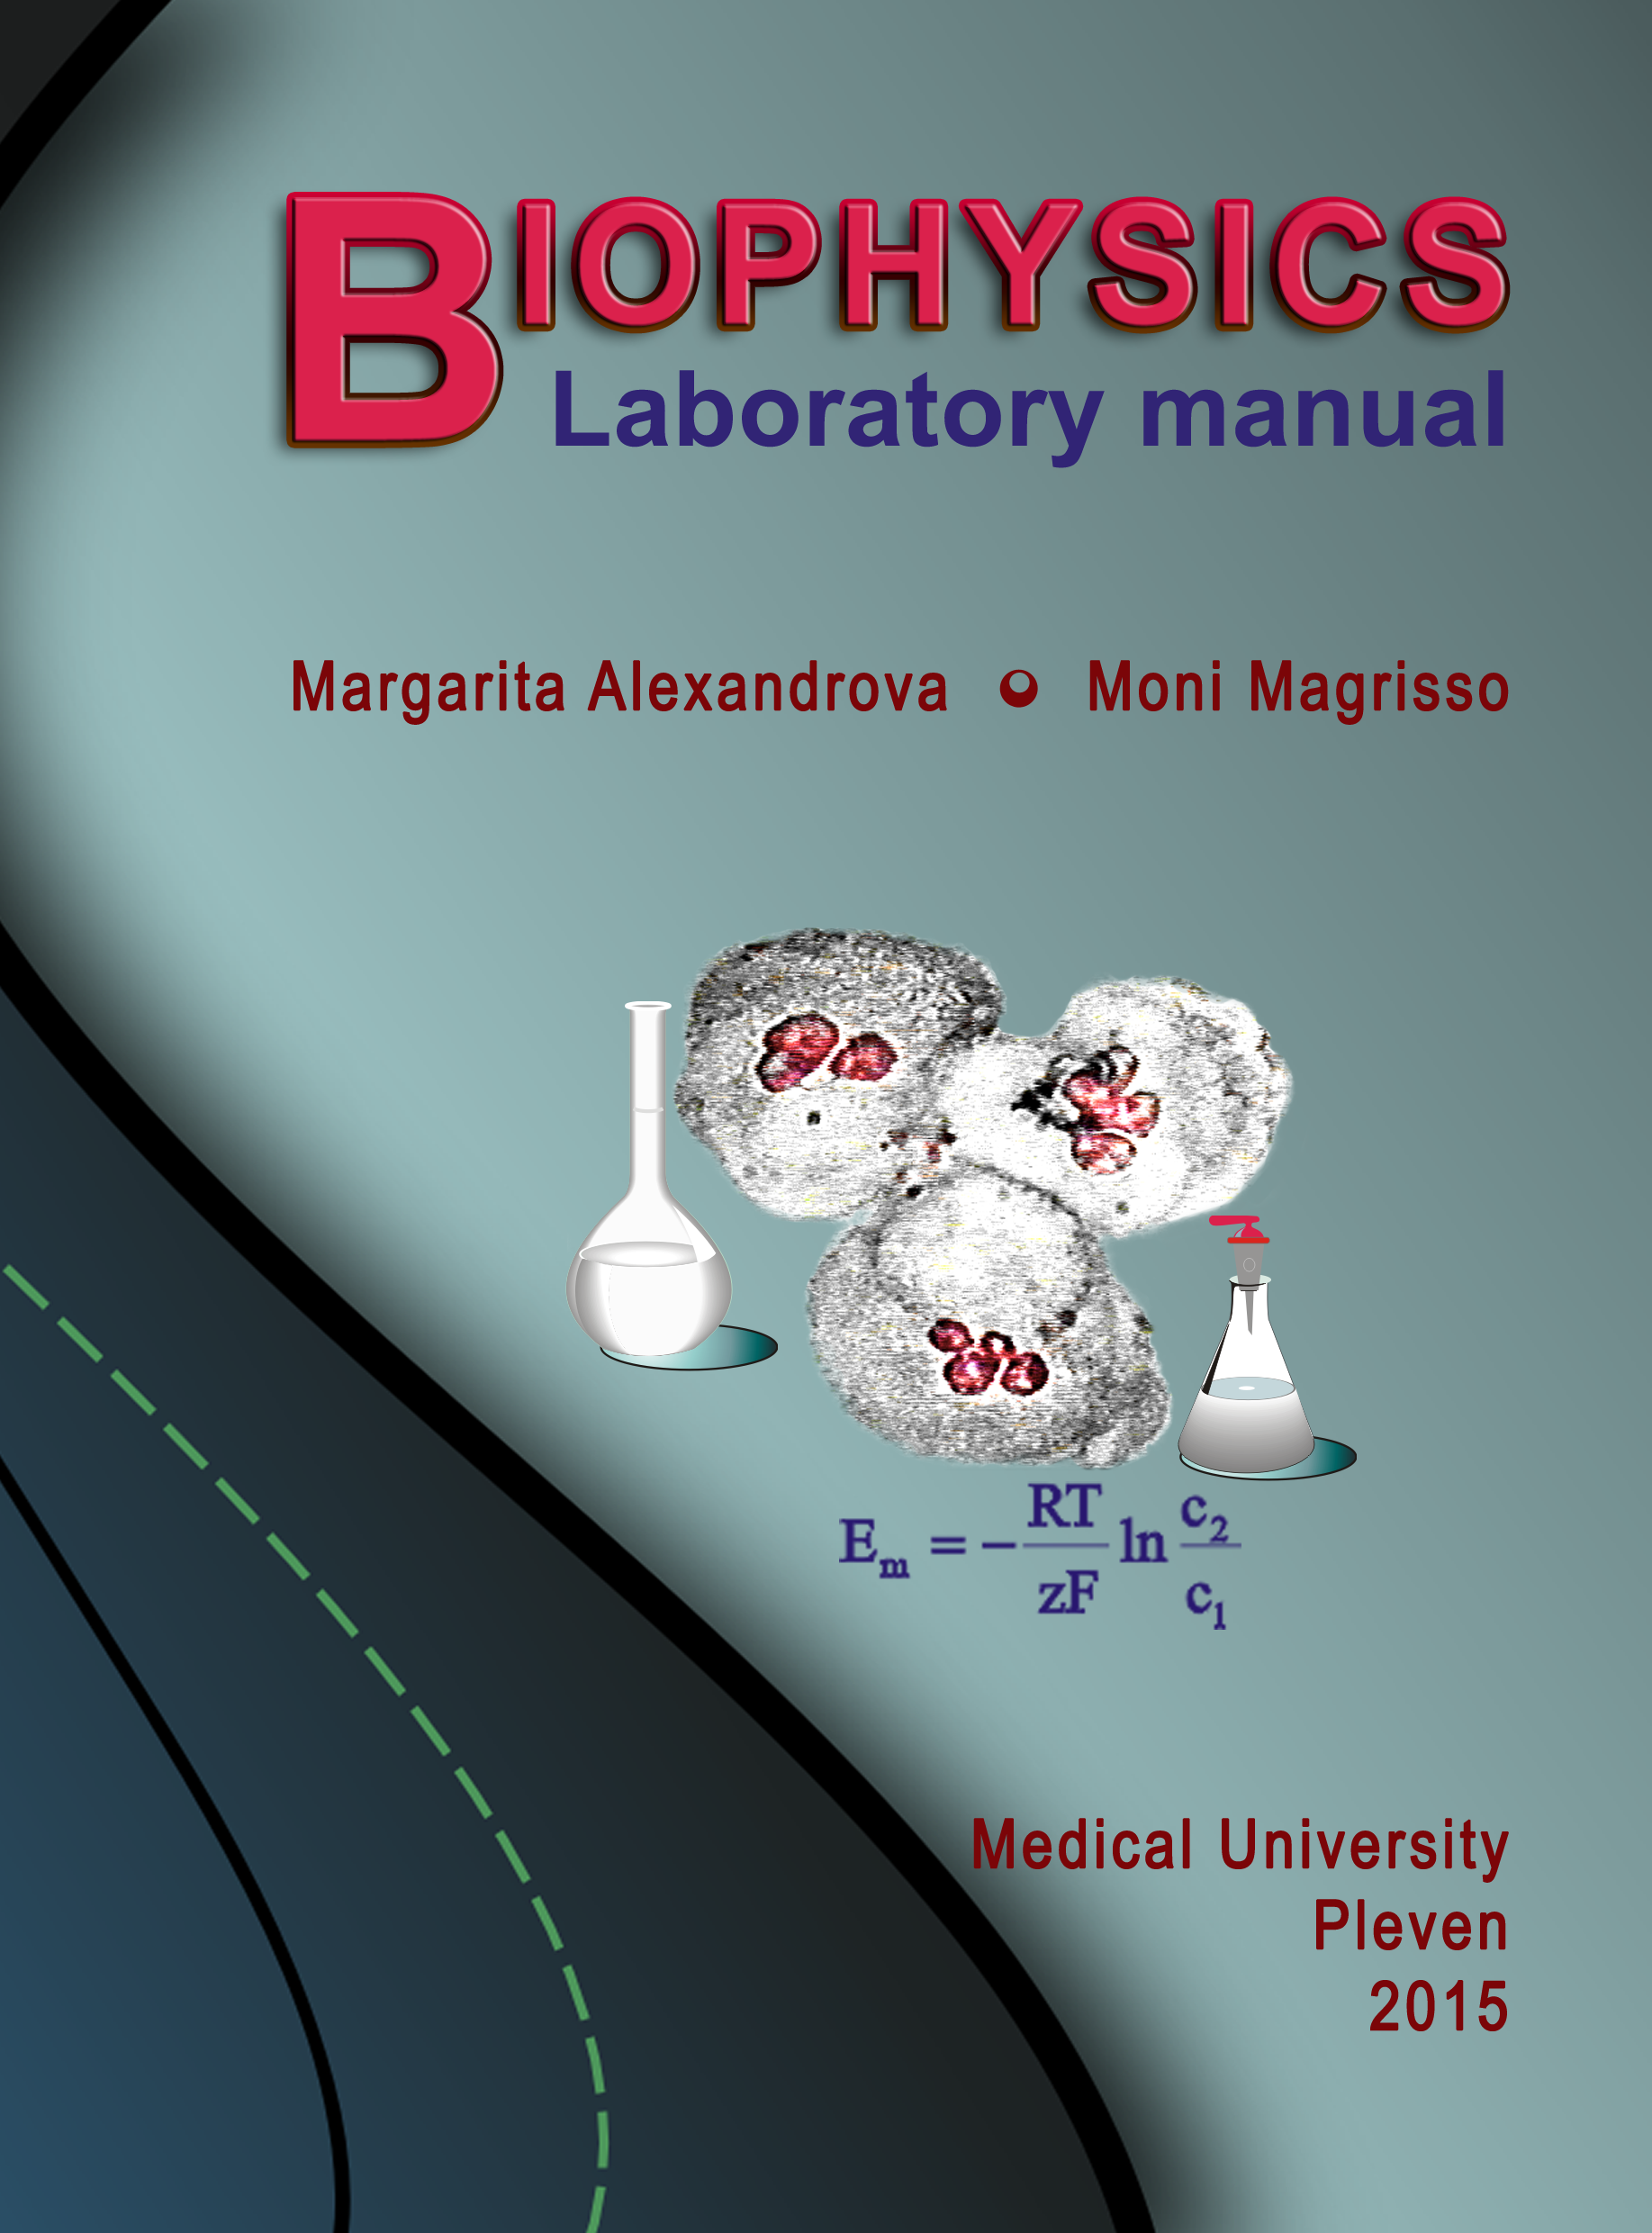 | Biophysics lab classes are organized in a way to build up hand-on skills step by step. The lab classes are compulsory.  The Biophysics Laboratory Manual includes thirteen topics. Every topic consists of five parts: objectives, theoretical background, laboratory report, questions and problems. According to the well-validated practice, students achieve best laboratory results if they have studied the corresponding theoretical part as well as references prior to recording experimental data. During the experiment, students have the opportunity to seek advice from, and discuss both methodology and results obtained with members of the teaching staff. Formal data submission and analysis is the final objective for students attending a course of biophysics.  The theses of the lab topics can be found using the link below.  File: Practical exercises – theses.docx
7. EXAMINATION SYNOPSIS IN BIOPHYSICS
The synopsis includes both lectures and lab exercises topics.
File: Examination synopsis in biophysics.docx

8. TEST QUESTIONS AND PROBLEMS
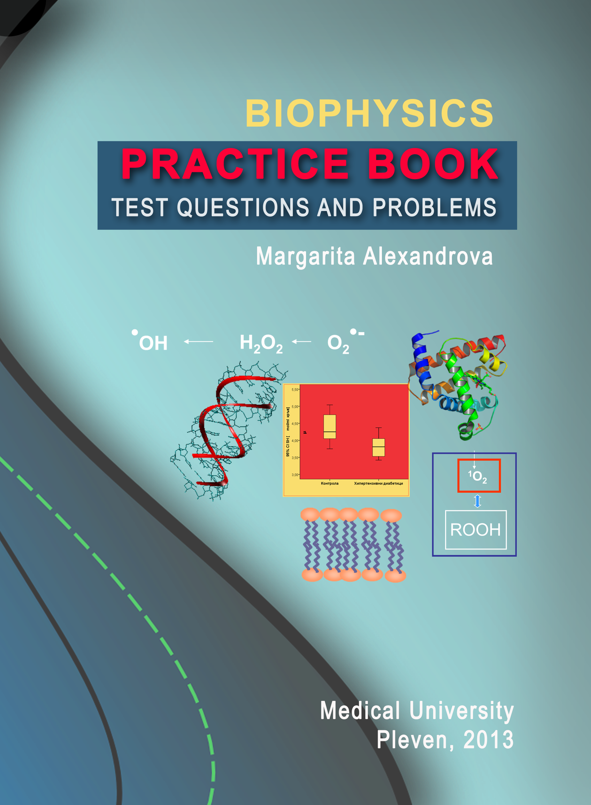 | At the end of the Biophysics course, students should be able to reason logically and state various biological problems in physical terms; They should be familiar with biothermodynamics, bioenergetics, biological transport processes, bioelectricity, and, free radical generation in human body and oxidative stress. To be prepared for the exam, students may use the Biophysics Practice Book. The practice book includes test questions and problems relating to each of the areas mentioned above. Problem-solving is a key part of the assessment for Biophysics.
9. Общи бележки и препоръки
10. Форум по дисциплината
11. Консултации

