MEDICAL PHYSICS

1. PURPOSE AND OBJECTIVES OF TRAINING
The discipline Medical Physics is in the list of compulsory subjects in the Medicine curriculum. It is studied in the first semester of the first year and ends with a semestral exam.
The aim of Medical Physics course is to deepen the specific scientific knowledge of medical students in the field of applications of physics to medicine and medical instrumentation.
This programme is intended to:
- provide education and training of high quality in Medical Physics;
- help students to understand the physical mechanisms underlying biological processes;
- provide students with a knowledge on the application of physical devices for diagnosis and treatment of diseases.

2. TEACHING TEAM
Lecturer:
- Prof. Margarita Alexandrova, DSc, PhD, Master in Physics, specialties: Biophysics; Solid state electronics and optoelectronics; room 239, tel.: 064 884 162
E- mail: margalexandrova@yahoo.com
Assistant professors:
- Victoria Varbanova, MS, specialties: Optics and spectroscopy, Teacher in Physics and Astronomy; room 234, tel. 064 884 163; E- mail: viki_varbanova@abv.bg
- Veselin Ganev, PhD, Master in chemistry; specialty Technology of organic synthesis and rubber; room 241, tel. 064 884 173; E- mail: vesselin.ganev@gmail.com
- Daniela Uzunova, Master in Physics, specialty Laser techniques and technologies, Teacher in Physics; room 234, tel. 884 163; E- mail: douzounova@yahoo.com

3. PROGRAM OF STUDY
The Medical Physics Program of study is developed in the Department of Physics and Biophysics according to the System of quality of education. The content of the program was initially approved by the Department council and finally - by the Faculty council. The program includes the thesis plan of lectures and laboratory exercises. Its content is annually updated in accordance with the latest discoveries in the field.

File: Program of study.doc

4. LECTURE COURSE
The lecture course is intended for medical students. The course comprises fifteen 3 hours-lectures. A detailed presentation is given for them.
Files:
Lecture 1.pdf; Lecture 2.pdf; Lecture 3.pdf; Lecture 4.pdf; Lecture 5.pdf
5. ADDITIONAL MATERIALS
To help students prepare for the Medical Physics exam and to extend the students' learning, the following study materials listed below are recommended.
- Nave C, Nave B. Physics for the Health Sciences. 3rd edition, ©1985 Saunders Company
- Davidovits P. Physics in Biology and Medicine. 3rd Edition, © 2008, Elsevier Inc.
- Hobbie RK, Roth BJ. Intermediate Physics for Medicine and Biology. 4th Edition © 2007 Springer Science+Business Media, LLC

6. LABORATORY EXERCISES
Physics lab classes are organized in a way to build up hand-on skills step by step. The lab classes are compulsory.
The Physics Laboratory Manual includes thirteen topics. Every topic consists of five parts: objectives, theoretical background, laboratory report, questions and problems. According to the well-validated practice, students achieve best laboratory results if they have studied the corresponding theoretical part as well as references prior to recording experimental data. During the experiment, students have the opportunity to seek advice from, and discuss both methodology and results obtained with members of the teaching staff.
The theses of the lab topics can be found using the link below.
File: Practical exercises – theses.doc
7. EXAMINATION SYNOPSIS IN PHYSICS
The synopsis includes both lectures and lab exercises topics.
File: Synopsis.doc

8. TEST QUESTIONS AND PROBLEMS
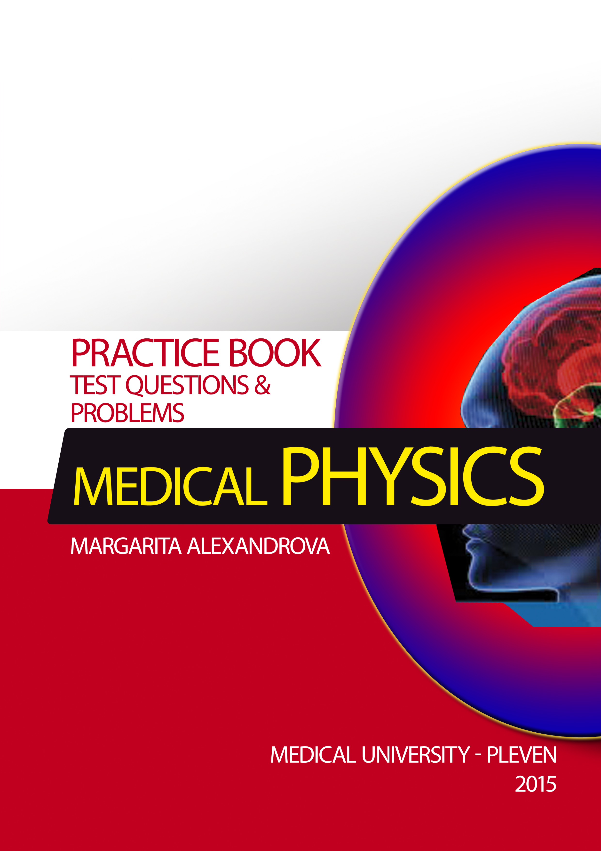 | The Medical Physics Practice book is designed to help students to assess their knowledge of medical physics and their ability to apply physical principles in the solution of biological and medical problems. The questions are assembled in accordance with the lecture course in Medical Physics in Pleven Medical University. The practice book consists of different types of questions: true/false, multiple choice; fill in the blanks and numerical problems. The International System (SI) of units is used predominantly in it. A table of information representing various physical constants and a few conversion factors among SI units is presented, as well.
After completing the Medical Physics course students are expected to understand the basic concepts of physics in all its aspects, from mechanics to modern physics.
They are also expected
- to know physical methods and devices used for prophylaxis, therapy, treatment and control of physiological processes;
- to be acquainted with the effect of physical factors on human organism.

