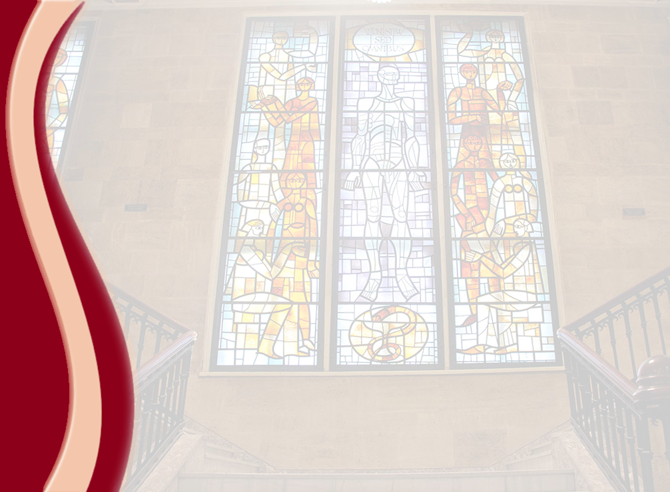
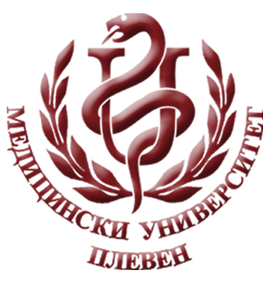
MEDICAL UNIVERSITY - PLEVEN
DISTANCE LEARNING CENTRE

MARGARITA ALEXANDROVA

PHYSICS

lecture course

FOR DISTANCE LEARNING

FOR STUDENTS IN MEDICAL UNIVERSITY – PLEVEN

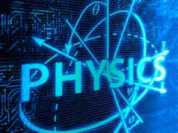

PLEVEN, 2016

