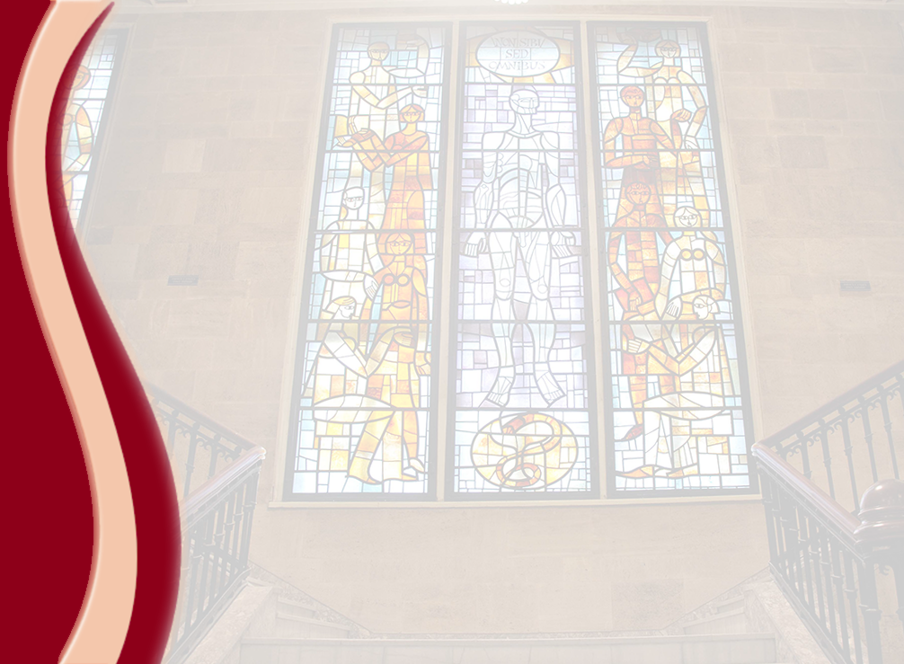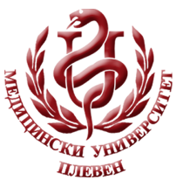 **MEDICAL UNIVERSITY - PLEVEN**

**DISTANCE LEARNING CENTRE**

**MARGARITA ALEXANDROVA**

**PHYSICS**

⚫lecture course⚫

**FOR DISTANCE LEARNING**

**FOR STUDENTS IN MEDICAL UNIVERSITY – PLEVEN**

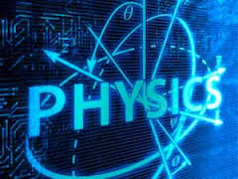

PLEVEN, 2016