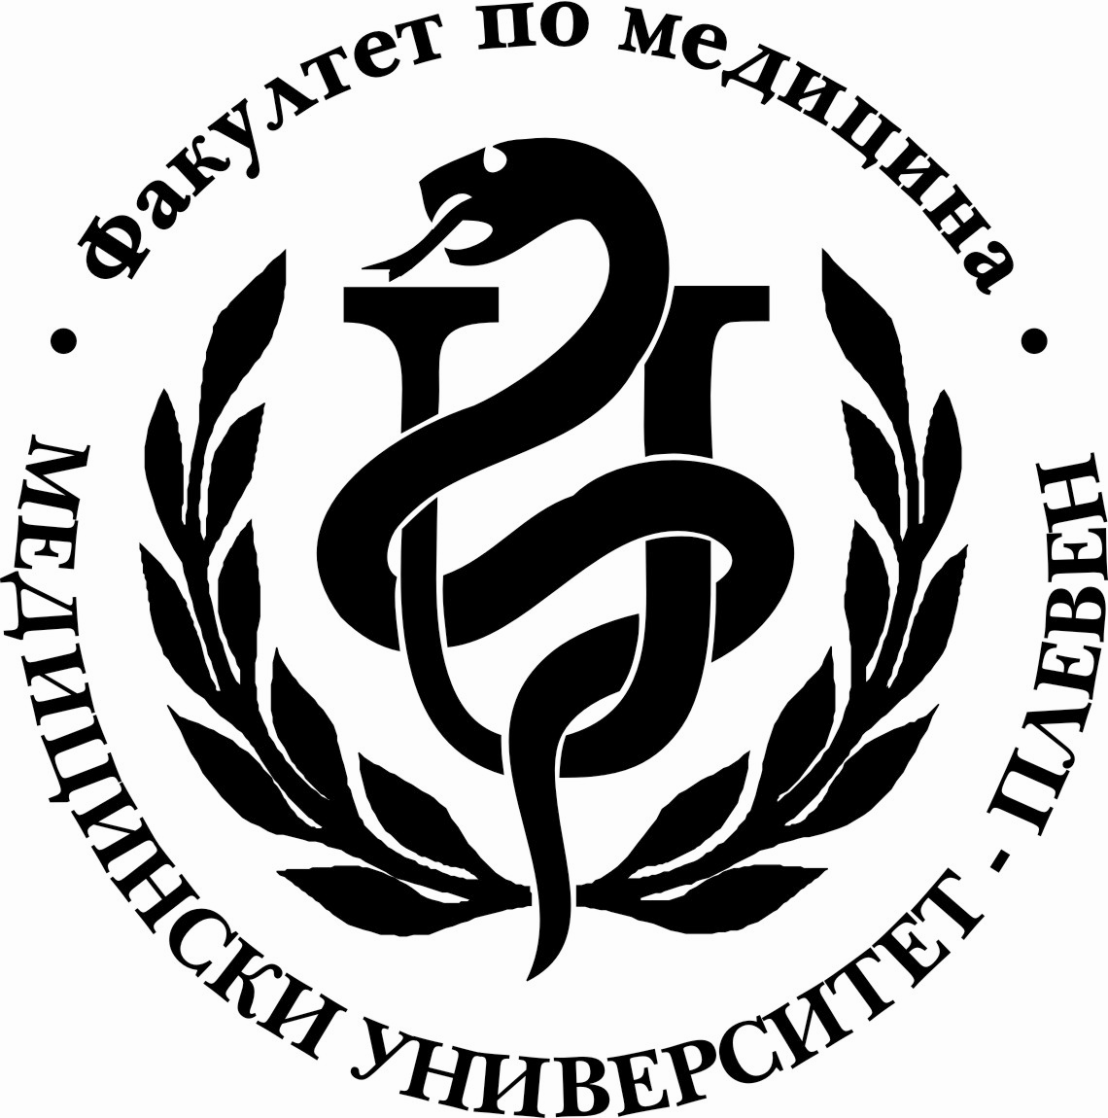
MEDICAL UNIVERSITY - PLEVEN

FACULTY OF MEDICINE

ANNOTATION OF SPECIALTY
"MEDICINE"
EDUCATIONAL QUALIFICATION DEGREE "MASTER’S"
Medical University – Pleven offers a full-time six-year course of training in the specialty of Medicine which is structured in the following way: 2 years of pre-clinical study, 3 years of clinical study, and one year of state clinical practice /internship/. For more information see Academic Curriculum.
All graduates are awarded a Master’s Degree diploma of completed higher medical education. The academic Master’s Degree is conferred to them along with the professional qualification “Physician“.
The studies are carried out in two courses according to the medium of instruction – in English and in Bulgarian language. The English-language-course students have to attend compulsory classes in Bulgarian language /6 hours a week/ for the first three years of training in order to be able to communicate with patients in the University hospital throughout their clinical studies.
Training in "Medicine" meets the highest national and international standards supporting the medical practice, in improving and maintaining healthcare. The training is realized through the systematic accumulation of knowledge and skills; through research; by activities for the community, ensuring a highly skilled and highly specialized medical and health care for the population and by comprehensive support from the academic community in solving public health problems and achieving the objectives of the health care reform in Bulgaria.
Clinical practice: educational practice for 30 days after the VIth and VIIIth semester; one year internship, which includes seven disciplines: Internal Medicine, Surgical Diseases, Obstetrics and Gynecology, Pediatrics, Hygiene, Epidemiology, Infectious Diseases and Social Medicine, Emergency Situations and optional-clinical practice.
Realization: graduates acquire the higher education degree "Master’s", with the professional qualification “Medical Doctor" who can be a general practitioner; a doctor in all kinds of therapeutic, diagnostic and consultative, preventative, social and others subdivisions of healthcare; a doctor in administrative offices and healthcare departments at municipal, regional and national levels.
Professional competence will allow the master - practitioner to continue his medical education through a system of specialization to obtain a certain medical specialty; to continue his studies with the "Medical Doctor’s" degree by all kinds of doctorates, according to the research interests; to apply and work as a research and teaching staff at the Medical University or other universities and research institutes, according to the capabilities and skills to build a career..

