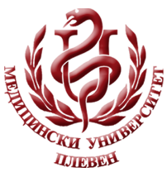**MEDICALUNIVERSITY - PLEVEN**

**DISTANCE LEARNING CENTRE**

**Prof. K. Todorova, MD,PhD**

**ENDOCRINOLOGY AND METABOLISM**

⚫Lecture course⚫

**FOR E-LEARNING**

**FOR STUDENTS AT MEDICAL UNIVERSITY– PLEVEN**



PLEVEN, 2015