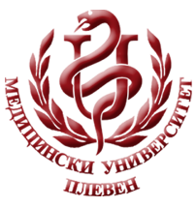**MEDICALUNIVERSITY - PLEVEN**

**DISTANCE LEARNING CENTRE**

**Prof. Katya Todorova MD, PhD**

⚫Endocrinology and metabolic diseases⚫

**FOR E-LEARNING**

**FOR STUDENTS AT MEDICAL UNIVERSITY–PLEVEN**

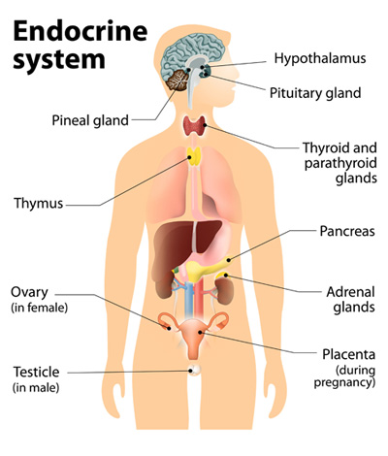

PLEVEN, 2017