DISASTER MEDICINE

Table 2.
1. PURPOSE AND OBJECTIVES OF TRAINING
Training in Disaster Medicine is focused on studying biological effects of ionizing radiation: effects on molecular, cellular and tissue levels, clinical features, treatment and prophylaxis of acute radiation syndromes and other radiation damage. Training is also focused on toxicological study of the most common occupational, domestic and accidental poisonings, their pathogenesis, clinical picture, prophylaxis and treatment. A substantial part of training is oriented to management of disaster situations – organization of medical care and triage in case of mass injuries, disasters and accidents.
2. TEACHING TEAM (FACULTY TEACHERS)
Lecturer:
- Assoc.Prof. Dr. Violeta Yordanova Dancheva , MD, PhD, Head of Sector of Disaster Medicine
- Tel: 064 884 288, e-mail: vilidana@abv.bg
3. PROGRAM OF STUDY (CURRICULUM)
The Disaster Medicine Program of study is developed in the Sector of Disaster Medicine according to the System of quality of education. The content of the program was initially approved by the Department council and finally - by the Faculty council. The Disaster Medicine program includes the thesis plan of lectures and laboratory exercises. Its content is annually updated in accordance with the latest discoveries in the field.

4. LECTURE COURSE
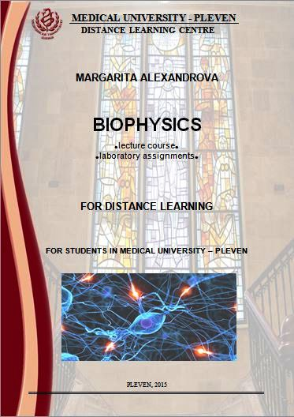 | The lecture course is intended for medical students. The course comprises fifteen 2 hour-lectures. A detailed presentation is given for some of them.  To the lecture course…
5. ADDITIONAL MATERIALS
To help students prepare for the Disaster Medicine exam and to extend the students' learning, the following study materials listed below are recommended.
- Salovsky P. Disaster medicine (detailed plans of lectures), 2014.
- General and Applied Toxicology, Bryan Ballanyne et al, 1994, Stockton.
- Medical Toxicology, Ellenhorn Matthew J., 1997, Williams and Wilkins.
- Industrial Toxicology, 1998, Hamilton and Hardy’s, Fifth Edition Ed. by Raymond D Harbison.
- Introduction to Radiobiology, Maurice Tubiana et al., 1990, Taylor and Francis, London-New York-Philadelphia.
- Handbook of Radiobiology, Prasad KN, 1995, Second Edition, CRC Press.
- Medical Radiobiology, Travis Elizabeth La Torre, Year book Medical Publishers, 1989, Inc. Chicago, London Boca Raton.
- The Public Health Consequences of Disasters, Ed. by Eric K Noji, 1997, Oxford University Press.

6. LABORATORY EXERCISES (ASSIGNMENTS AND ESSAYS, PRACTICAL EXERCISES)
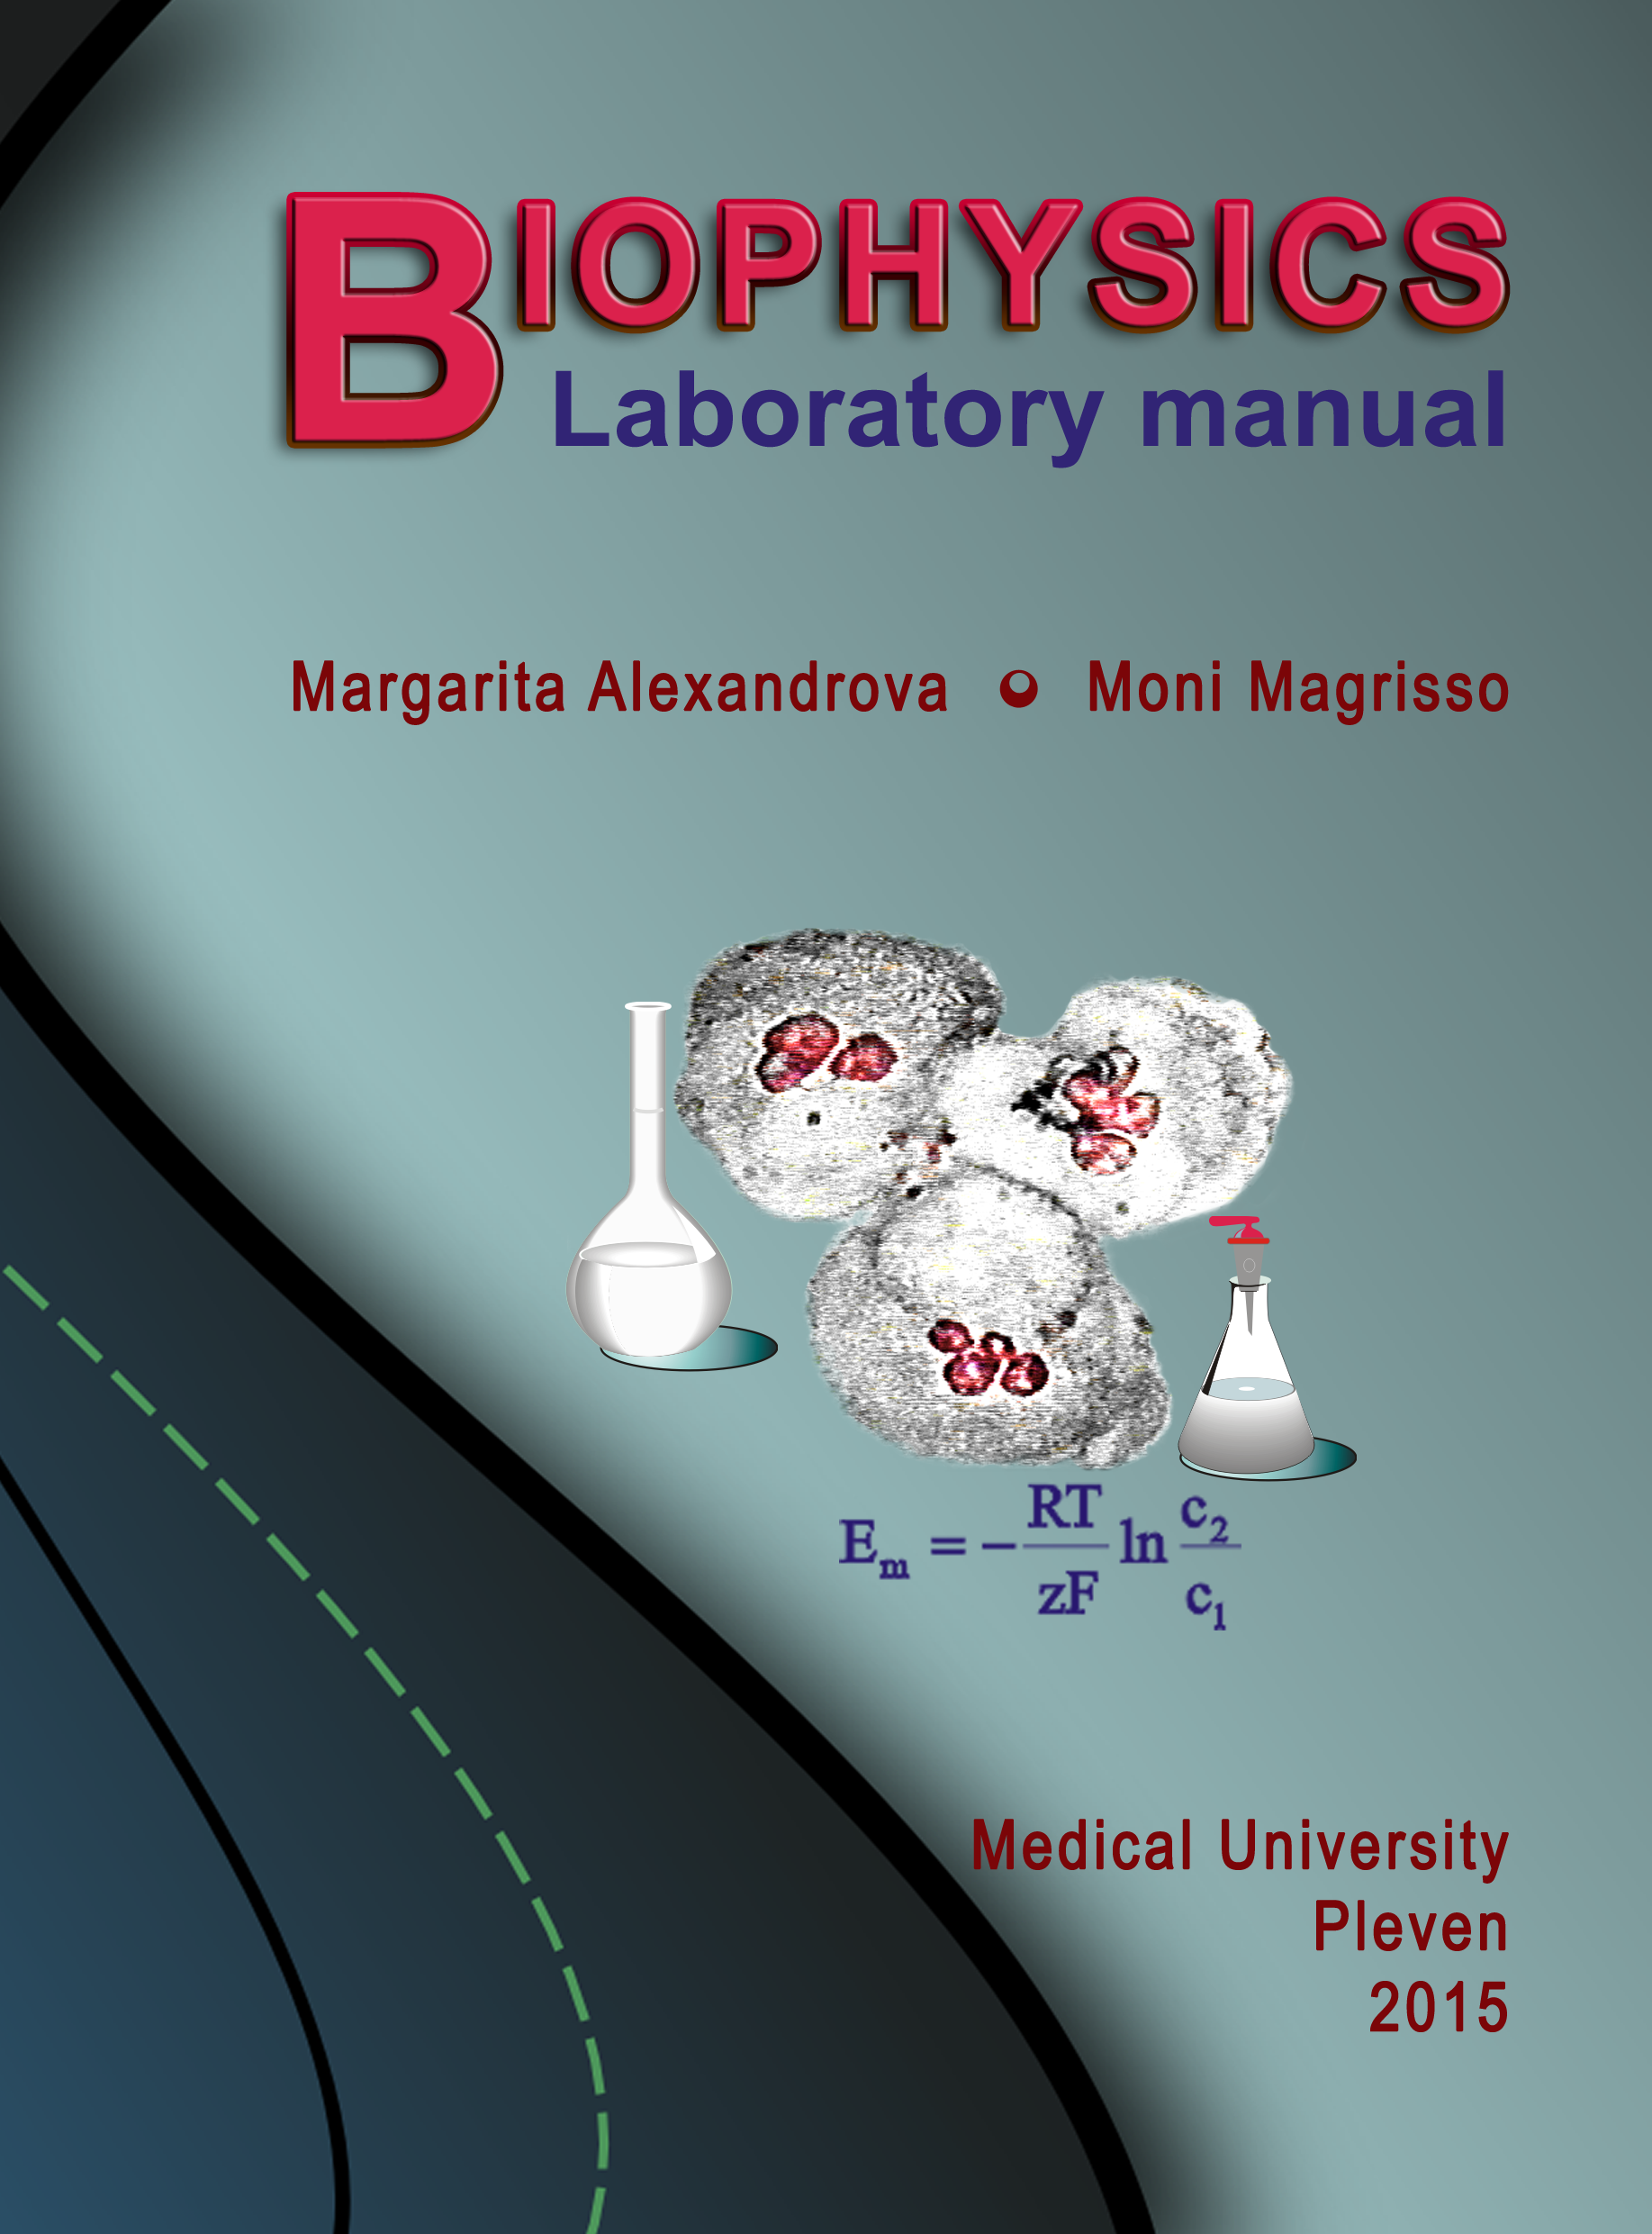 | The Disaster medicine practical exercises include seven topics/classes. The lab classes are compulsory.  The theses of the lab topics can be found using the link below.  File: Practical exercises – theses.docx
7. EXAMINATION SYNOPSIS IN DISASTER MEDICINE (CONSPECTUS FOR THE EXAM)
The synopsis includes both lectures and lab exercises topics.
File: Examination synopsis in disaster medicine.docx

8. TEST QUESTIONS AND PROBLEMS (TESTS COURSE)
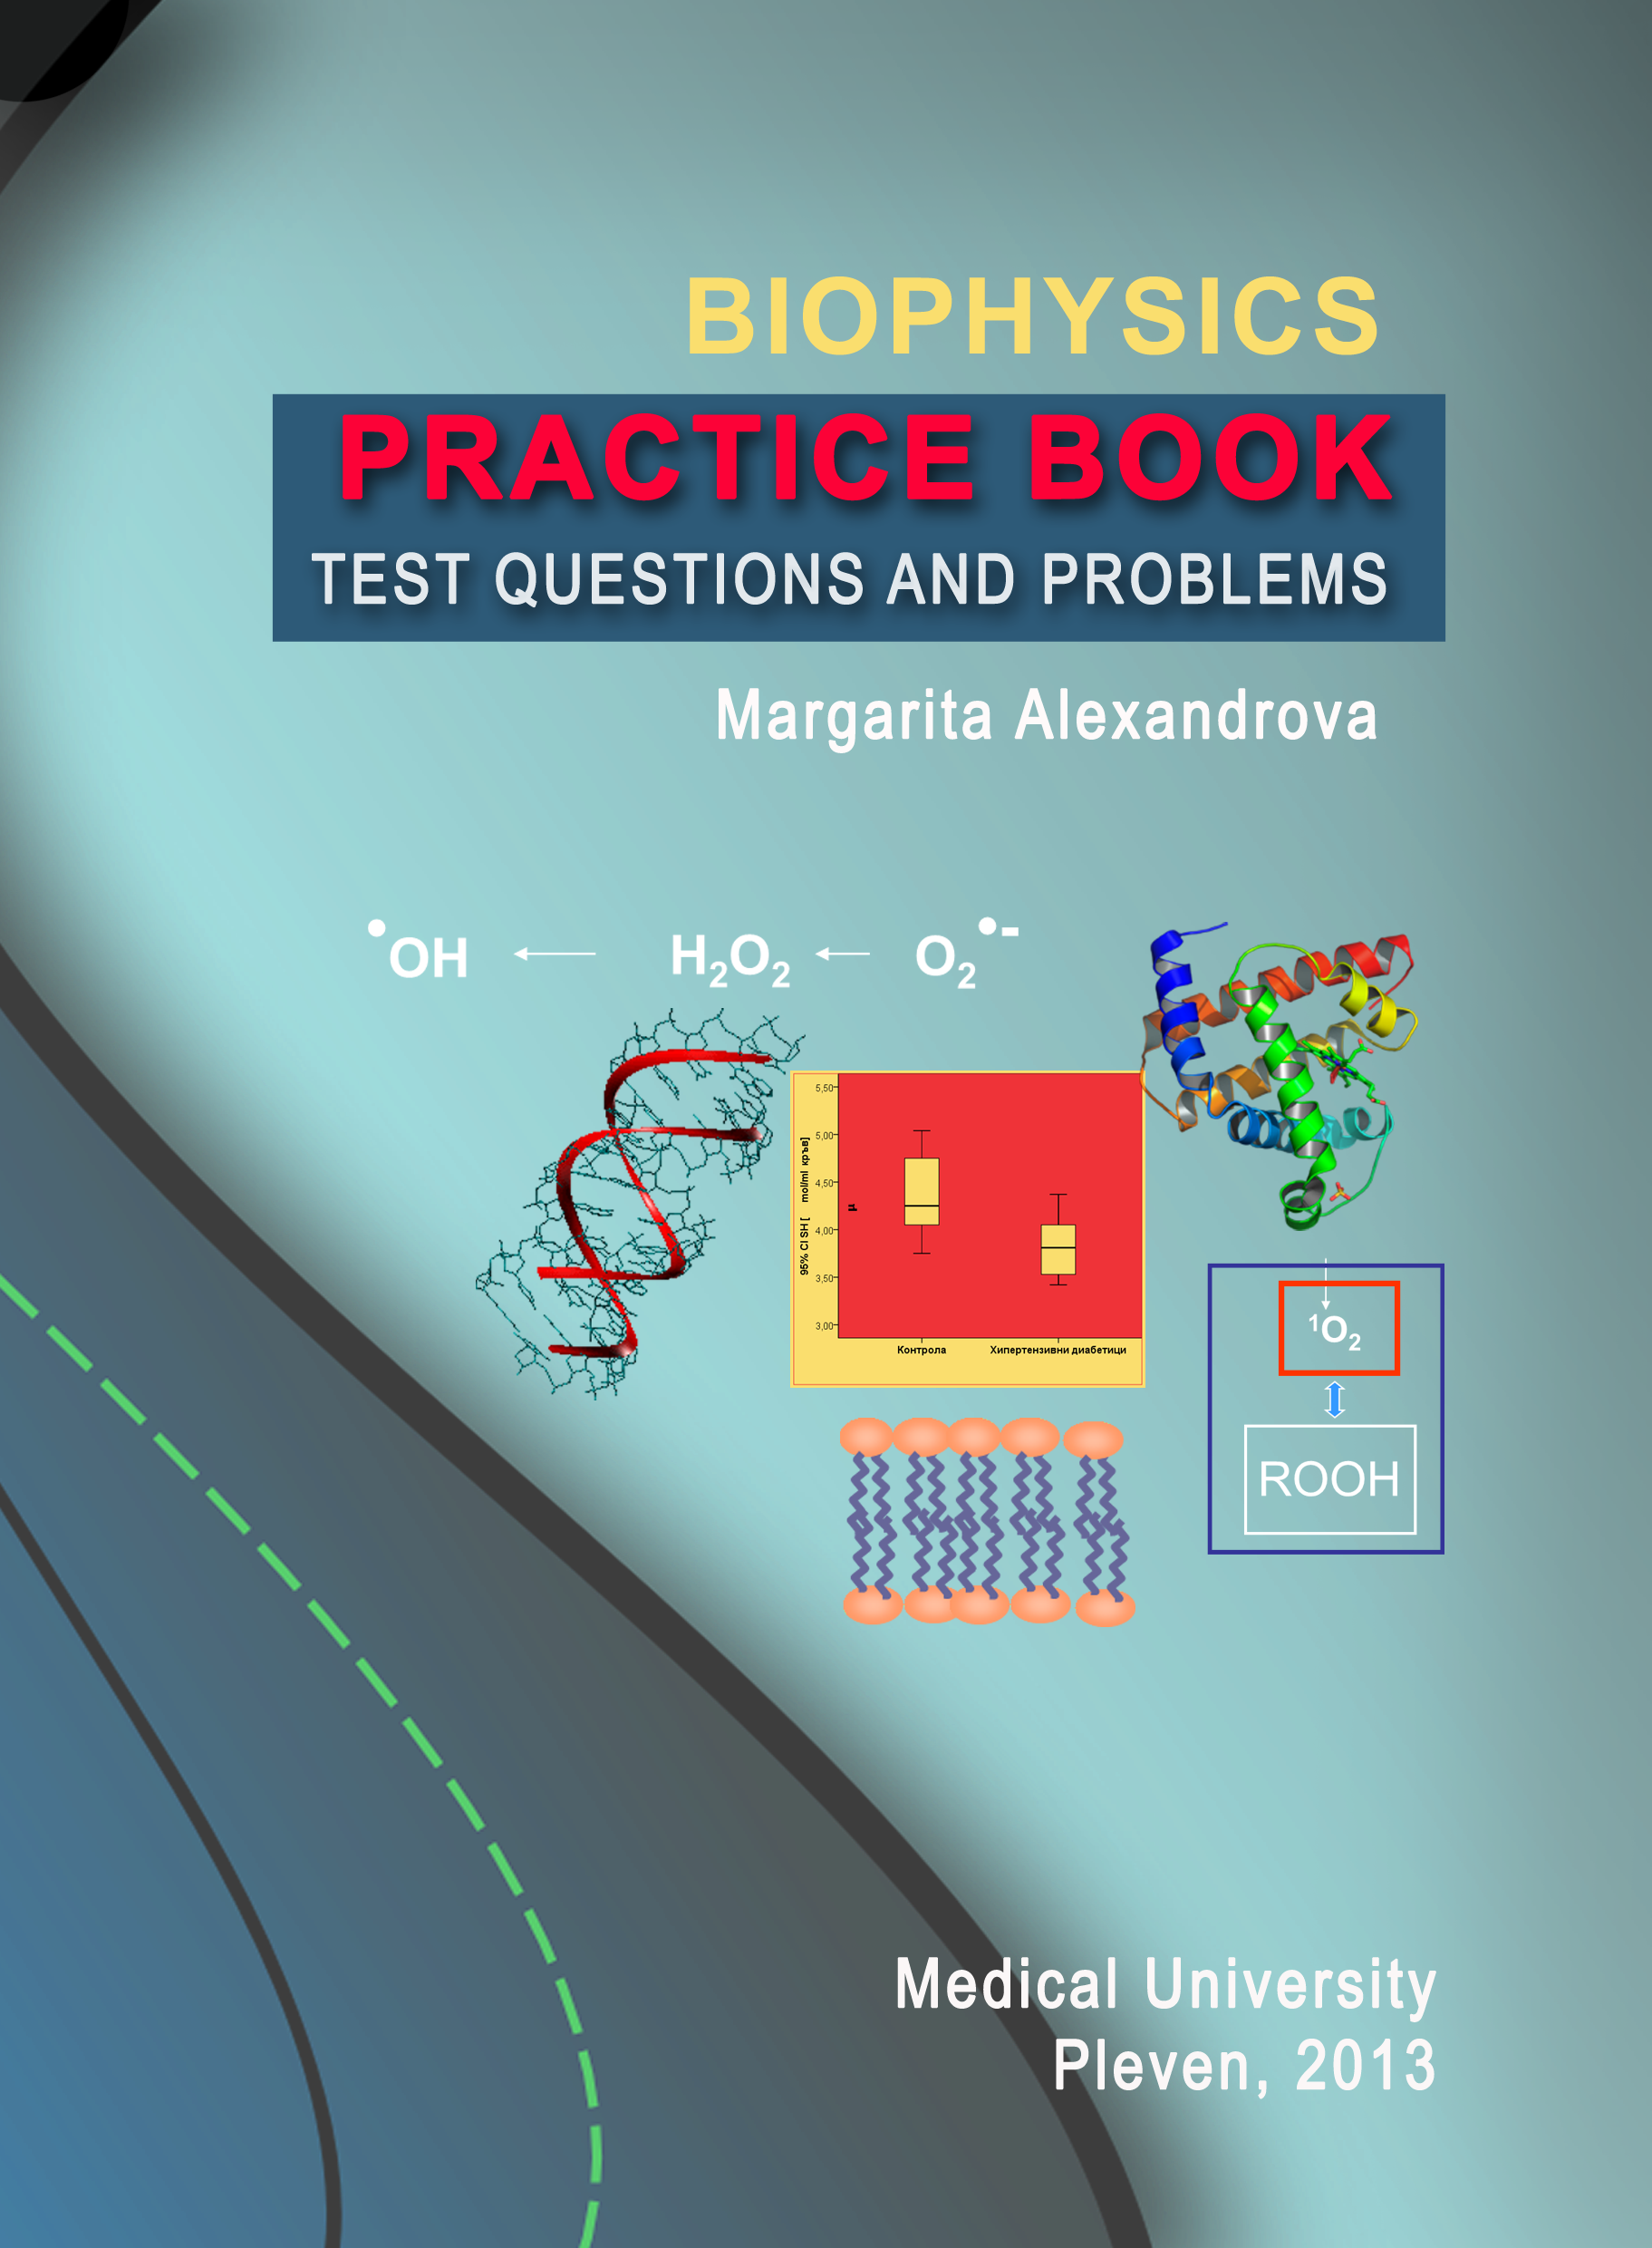
9. GENERAL COMMENTS AND RECOMMENDATIONS
The general comments and recommendations can be found using the link below.

File: Comments and recommendations.docx

10. FORUM ON THE DISCIPLINE
The forum on the subject is the place where you can accommodate comments, questions and recommendations on ways of presenting the material. The forum is open to all students and the information in it should be brief and clear in strict compliance with the requirements of academic ethics. Thank you for your understanding.
11. CONSULTATIONS
Consultations on the course are in attendance and remote form. Attendance consultations are optional and are held in the Disaster Medicine unit - Pleven at the appointed time. These consultations explain the methodology and terms of preparation for the course in distance learning. In remote consultation teachers contact with the students through forums and email.

Table 2.
Lecture 2: General toxicology. Basic concepts. Nature of toxic effects. Biotransformation of xenobiotics. Principles of therapy of intoxication.
History. Basic concepts. Toxicology terminology. Systemic and organ toxins. Factors determining adverse effects. Routes of Exposure. Nature of toxic effects. Classification of toxic agents. Biotransformation of xenobiotics – Phase I and Phase II reactions. Factors affecting metabolism. Organ-directed toxicity. Principles of the therapy of intoxications: ABCDEs measures, GI decontamination, Measures to enhance elimination of the poisons - Diuresis (kinds), Extracorporeal techniques (dialysis – peritoneal and hemodialysis, hemoperfusion, hemofiltration, exchange transfusion).
 Presentation of Lecture 2... Files: Lecture _passive transport -10.ppt

Lecture 3: Toxicology of anticholinesterase pesticides. Toxicology of chemical warfare agents.
Anticholineserase pesticides. Sources and use. Mechanism of action. Clinical presentation. Diagnosis. Differential diagnosis. Treatment. Toxicology of chemical warfare agents.
Presentation of Lecture 3... Files: Lecture_resting potential-13.ppt

