BIOPHYSICS

Table 2.
1. PURPOSE AND OBJECTIVES OF TRAINING
The discipline Biophysics is in the list of compulsory subjects in the Medicine curriculum. It is studied in the second semester of the first year and ends with a semestral exam. One of the main objectives of medical biophysics is the identification of physical and physicochemical parameters for the purposes of objective diagnosing an organism’s functional state. Violation of life processes can be primarily judged by changes in these parameters. Characteristic properties of living cells are the presence of biopotentials, the ability to maintain ionic gradients and carry electric currents, the capability to produce chemiluminescence, etc. The objective of training in Biophysics is to teach students how to apply the concepts and methods of physical science to biological and medical problems. After completing the Biophysics Program students are expected to know the physical laws underlying physiological processes. The program has a strong emphasis on Biothermodynamics, Cellular Biophysics and Free Radical Generation and Oxidative Stress.

2. TEACHING TEAM (FACULTY TEACHERS)
Lecturer:
- Prof. Margarita Alexandrova, DSc, PhD, Master in Physics, specialties: Biophysics; Solid state electronics and optoelectronics; room 239, tel.: 064 884 162
E- mail: margalexandrova@yahoo.com
Assistant professors:
- Victoria Varbanova, MS, specialties: Optics and spectroscopy, Teacher in Physics and Astronomy; room 234, tel. 064 884 163;
E- mail: viki_varbanova@abv.bg
- Marko Kolaksuzov, PhD, Master in Biology; specialties: Plant Physiology, Plant Biotechnologies; room 241, tel. 064 884 173; E- mail: marko_i_k@abv.bg
- Veselin Ganev, PhD, Master in chemistry; specialty Technology of organic synthesis and rubber; room 241, tel. 064 884 173; E- mail: vesselin.ganev@gmail.com

3. PROGRAM OF STUDY (CURRICULUM)
The Biophysics Program of study is developed in the Department of Physics and Biophysics according to the System of quality of education. The content of the program was initially approved by the Department council and finally - by the Faculty council. The Biophysics program includes the thesis plan of lectures and laboratory exercises. Its content is annually updated in accordance with the latest discoveries in the field.

File: Program of study.docx

4. LECTURE COURSE
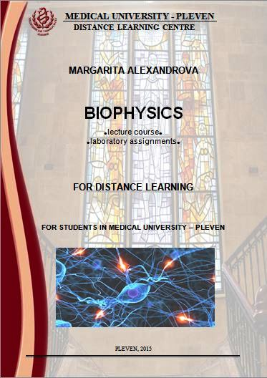 | The lecture course is intended for medical students. The course comprises fifteen 2 hour-lectures. A detailed presentation is given for some of them.  To the lecture course…
5. ADDITIONAL MATERIALS
To help students prepare for the Biophysics exam and to extend the students' learning, the following study materials listed below are recommended.
- Glaser R, Biophysics. Springer Science & Business Media, 2001 - Science - 361 pages
- Roy RN (1999) A textbook of biophysics (For medical science and biological students). New central book agency(p) Ltd.
- Davidovits P. Physics in Biology and Medicine. 3rd Edition, © 2008, Elsevier Inc.

6. LABORATORY EXERCISES (ASSIGNMENTS AND ESSAYS, PRACTICAL EXERCISES)
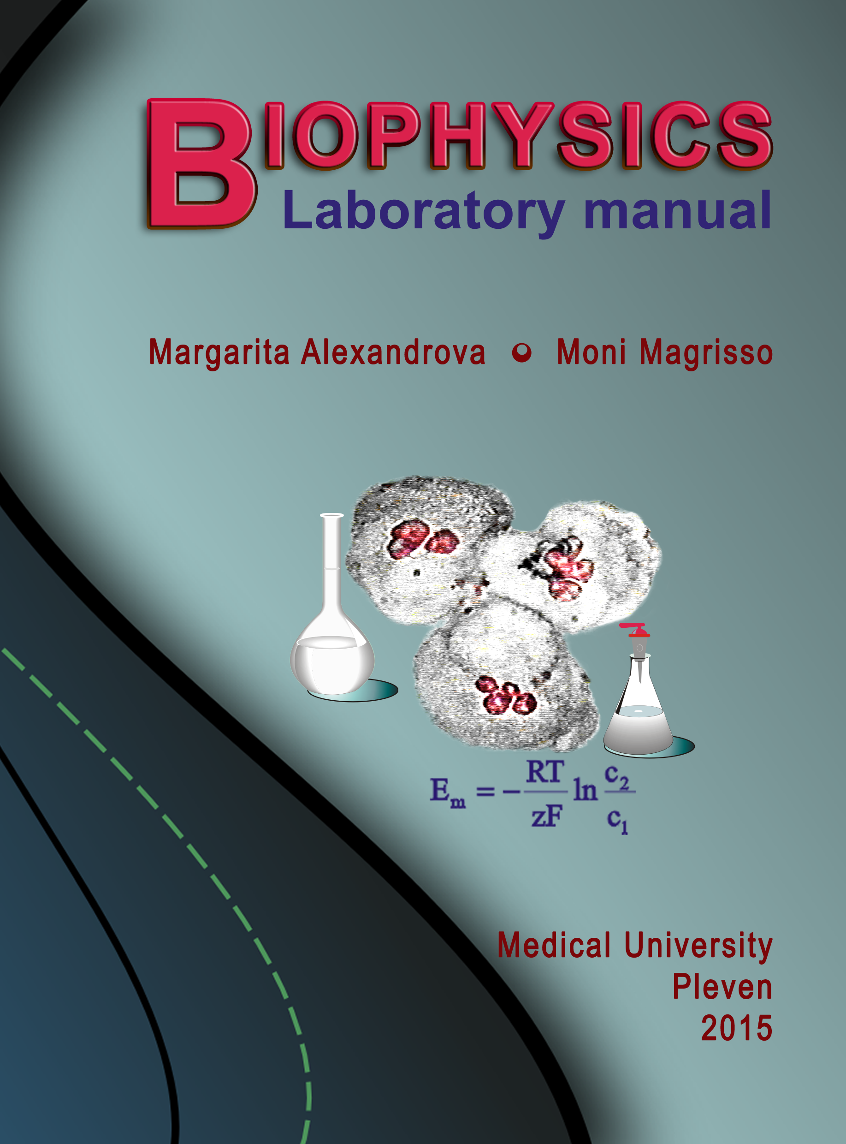 | Biophysics lab classes are organized in a way to build up hand-on skills step by step. The lab classes are compulsory.  The Biophysics Laboratory Manual includes thirteen topics. Every topic consists of five parts: objectives, theoretical background, laboratory report, questions and problems. According to the well-validated practice, students achieve best laboratory results if they have studied the corresponding theoretical part as well as references prior to recording experimental data. During the experiment, students have the opportunity to seek advice from, and discuss both methodology and results obtained with members of the teaching staff. Formal data submission and analysis is the final objective for students attending a course of biophysics.  The theses of the lab topics can be found using the link below.  File: Practical exercises – theses.docx
7. EXAMINATION SYNOPSIS IN BIOPHYSICS (CONSPECTUS FOR THE EXAM)
The synopsis includes both lectures and lab exercises topics.
File: Examination synopsis in biophysics.docx

8. TEST QUESTIONS AND PROBLEMS (TESTS COURSE)
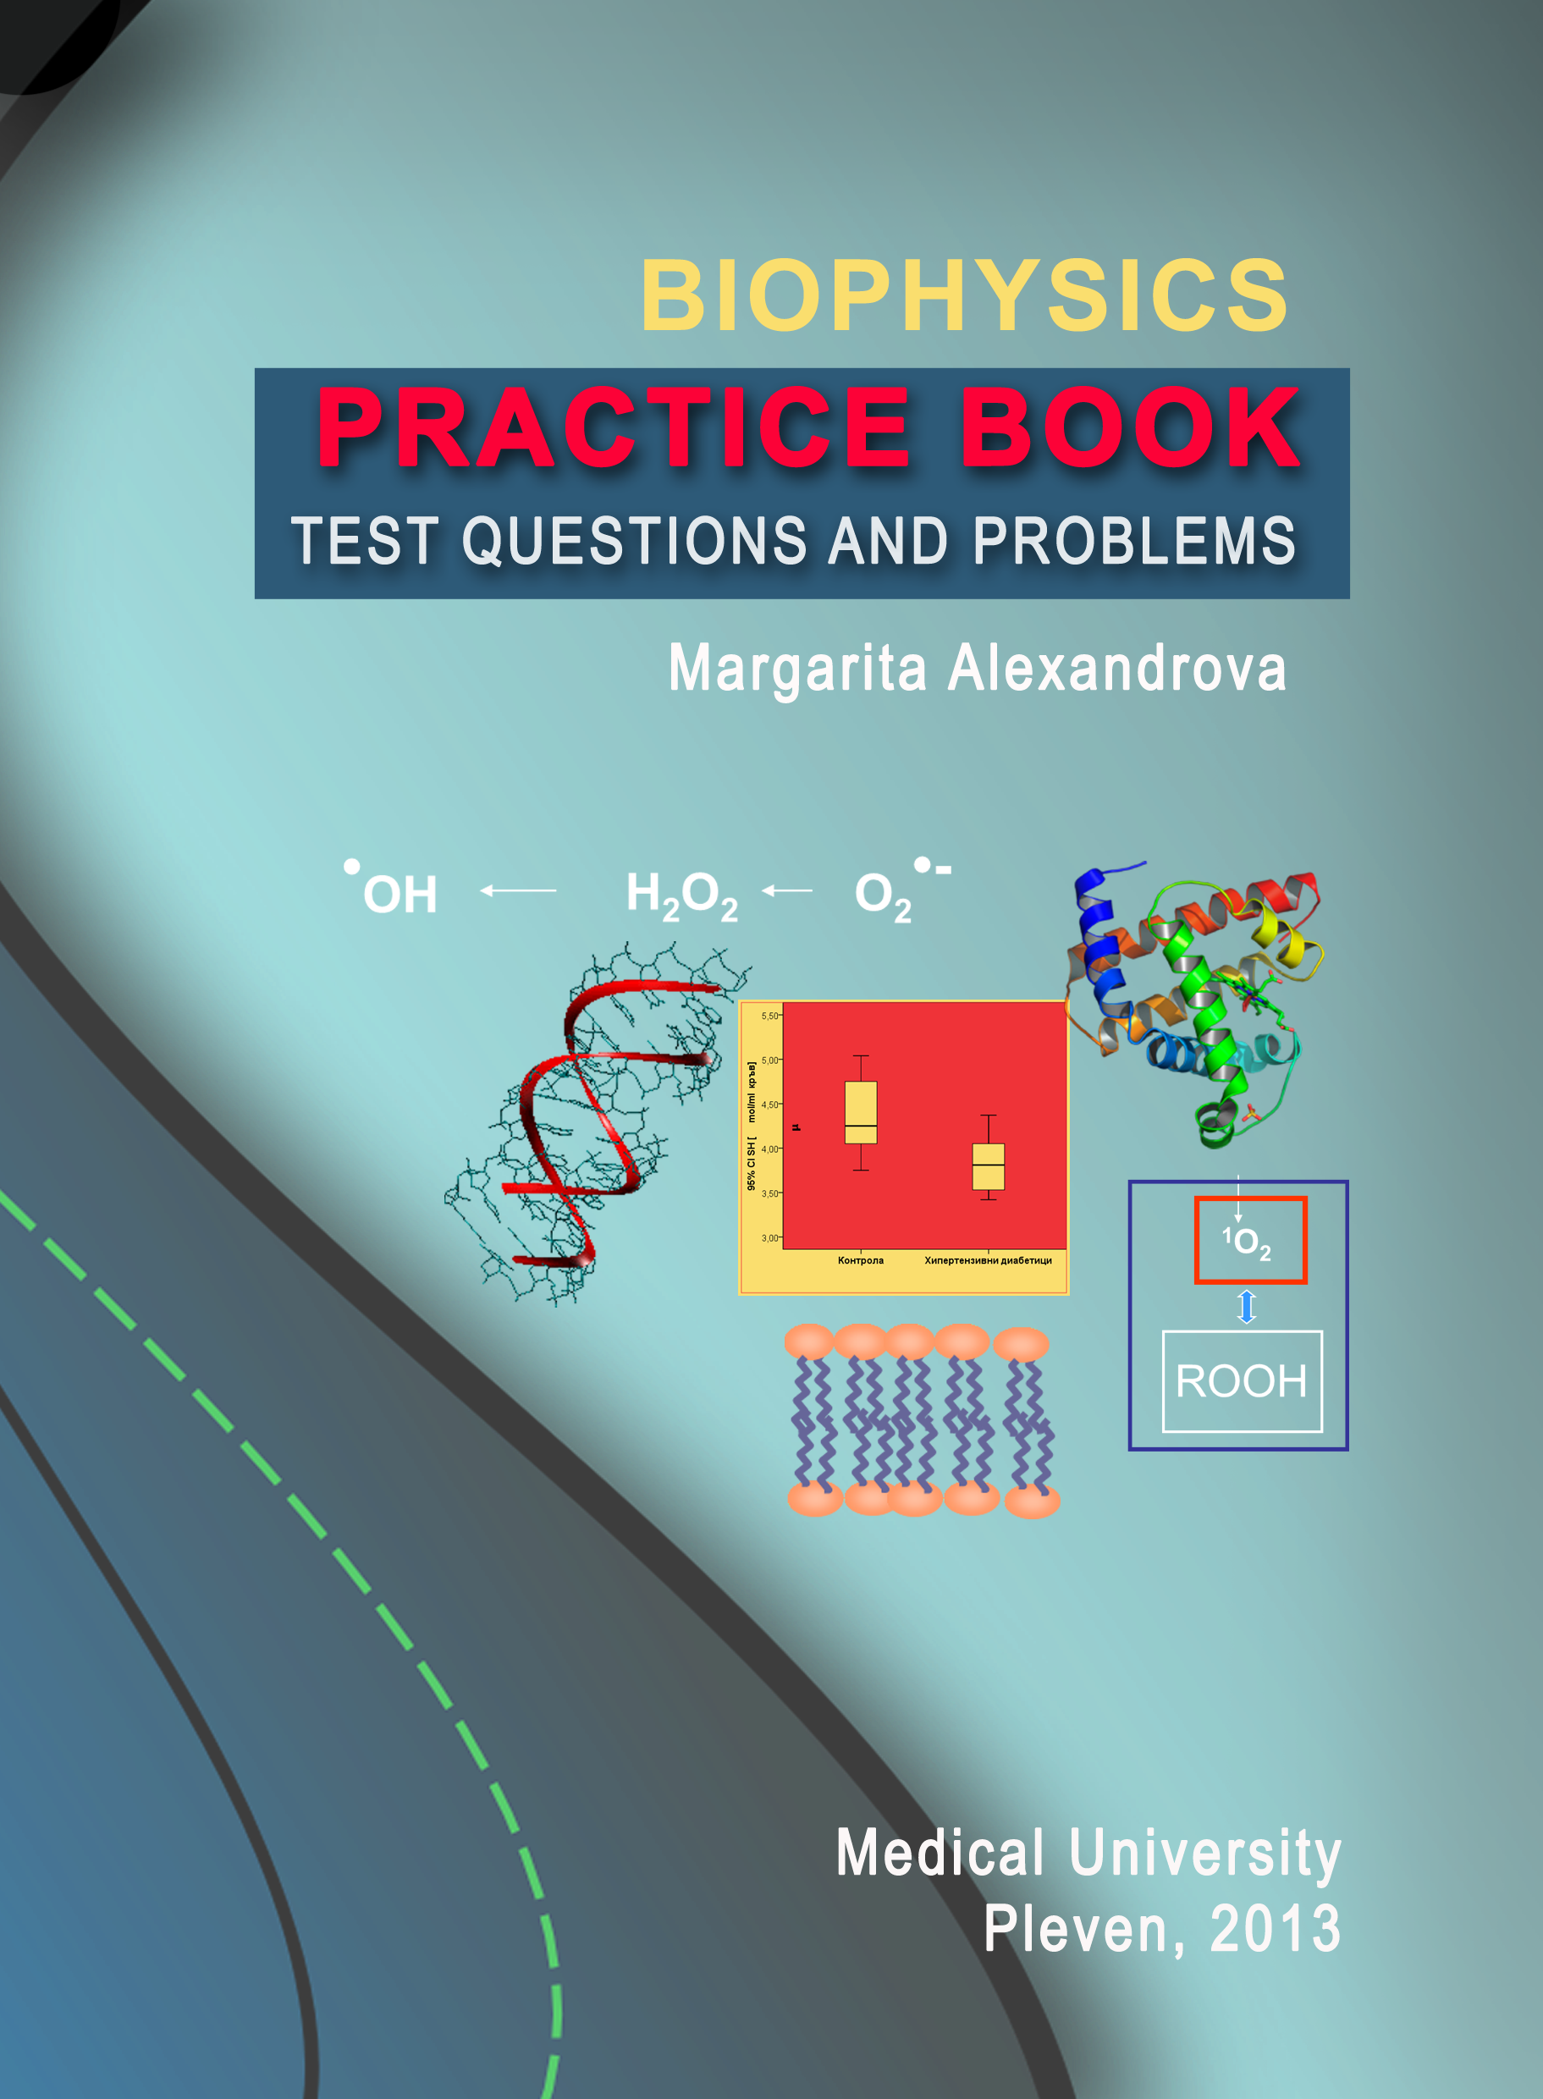 | At the end of the Biophysics course, students should be able to reason logically and state various biological problems in physical terms; They should be familiar with biothermodynamics, bioenergetics, biological transport processes, bioelectricity, and, free radical generation in human body and oxidative stress. To be prepared for the exam, students may use the Biophysics Practice Book. The practice book includes test questions and problems relating to each of the areas mentioned above. Problem-solving is a key part of the assessment for Biophysics.
9. GENERAL COMMENTS AND RECOMMENDATIONS
In relation to this section contains instructions on how to prepare for the course. There is information on the requirements for preparation of individual course tasks. There have been a number of recommendations on how the preparation and resolution of selection tests.

The general comments and recommendations can be found using the link below.

File: Comments and recommendations.docx

10. FORUM ON THE DISCIPLINE
The forum on the subject is the place where you can accommodate comments, questions and recommendations on ways of presenting the material. The forum is open to all students and the information in it should be brief and clear in strict compliance with the requirements of academic ethics. Thank you for your understanding.
11. CONSULTATIONS
Consultations on the course are in attendance and remote form. Attendance consultations are optional and are held in the Biophisics unit - Pleven at the appointed time. These consultations explain the methodology and terms of preparation for the course in distance learning. In remote consultation teachers contact with the students through forums and email.

Table 2.
Lecture 10: Transport of matter across cell membranes - classification.
Classification on the basis of transport mechanism, energy supply, number of transported species and direction of their translocation, trans-membrane potential changes. Passive transport. Free diffusion of non-charged and charged particles. Fick's law. Free diffusion of charged particles. Nernst-Planck molar flux equation. Simple diffusion through membranes. Permeability. Transport of water through membranes. Filtration and osmosis. Facilitated diffusion. Transport by carrier proteins. Saturability and specificity - important characteristics of the membrane transport systems. Transport by channels and pores. Three examples of pores important for cellular physiology.

 Presentation of Lecture 10... Files: Lecture _passive transport -10.ppt

Lecture 13: Generation of resting membrane potential.
The Goldman and Thomas equations. Factors contributing to the resting potential.

Presentation of Lecture 10... Files: Lecture_resting potential-13.ppt

