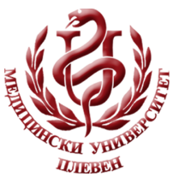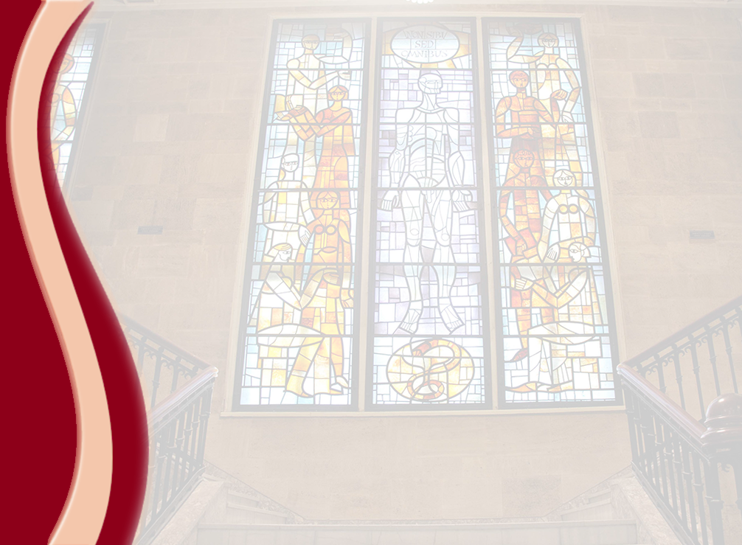 **MEDICAL UNIVERSITY - PLEVEN**

**DISTANCE LEARNING CENTRE**

**Assoc. Prof. Boryana Ruseva, MD, PhD**

**PHYSIOLOGY**

⚫lecture course⚫

**FOR E-LEARNING**

**FOR STUDENTS AT MEDICAL UNIVERSITY – PLEVEN**

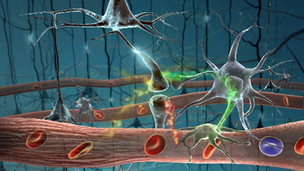

PLEVEN, 2017