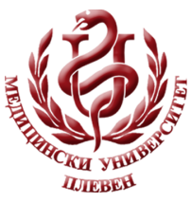 **MEDICAL UNIVERSITY - PLEVEN**

**DISTANCE LEARNING CENTRE**

**ASSOC. PROF. BORYANA RUSEVA, MD, PhD**

**PHYSIOLOGY**

⚫ lecture course ⚫

**FOR E-LEARNING**

**FOR STUDENTS AT MEDICAL UNIVERSITY – PLEVEN**

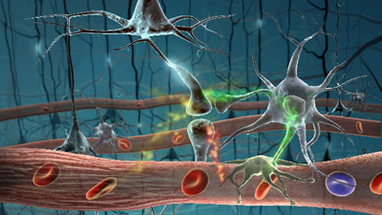

PLEVEN, 2017