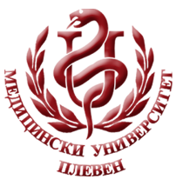 **MEDICAL UNIVERSITY - PLEVEN**

**DISTANCE LEARNING CENTRE**

**Assoc. Prof. Ch. Petrova, PhD**

**Assoc. Prof. B. Shentov, PhD**

**Assoc. Prof. N. Balgaranov, PhD**

**Assoc. Prof. R. Markova, PhD**

**PEDIATRICS**

⚫lecture course⚫

**FOR E-LEARNING**

**FOR STUDENTS AT MEDICAL UNIVERSITY – PLEVEN**



PLEVEN, 2020