
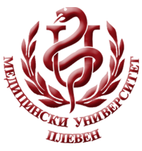
MEDICAL UNIVERSITY - PLEVEN
DISTANCE LEARNING CENTRE

Assoc. Prof. Dr. Milena Karcheva, MD, PhD
Assoc. Prof. Dr. Tanya Petkova, MD, PhD

INFECTIOUS DISEASE EPIDEMIOLOGY

lecture course

FOR E-LEARNING

FOR STUDENTS AT MEDICAL UNIVERSITY – PLEVEN



PLEVEN, 2020

