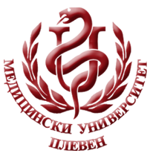 **MEDICAL UNIVERSITY - PLEVEN**

**DISTANCE LEARNING CENTRE**

**Assoc. Prof. Dr. Milena Karcheva, MD, PhD**

**Assoc. Prof. Dr. Tanya Petkova, MD, PhD**

**INFECTIOUS DISEASE EPIDEMIOLOGY**

⚫lecture course⚫

**FOR E-LEARNING**

**F OR STUDENTS AT MEDICAL UNIVERSITY – PLEVEN**



PLEVEN, 2020