**QUIZ 8**

1. Which of the mentioned peripheral nerves is affected in the **carpal tunnel syndrome:**
2. Ulnar nerve
3. Femoral nerve
4. Radial nerve
5. Tibial nerve
6. Median nerve
7. Which peripheral nerve is damaged in the picture below?

………………………………………………………….

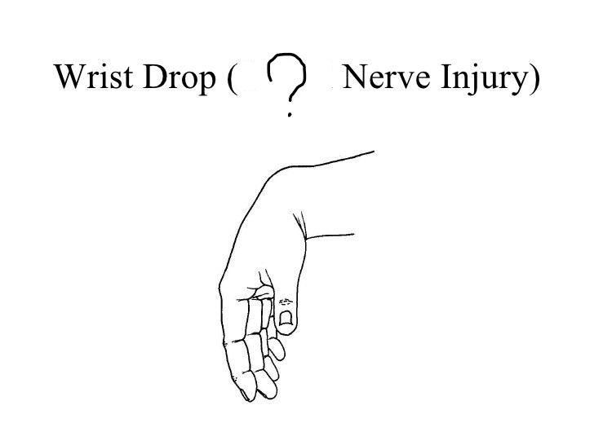

1. When a lesion of the sciatic nerve is present, a specific symptom becomes positive. What is that symptom called?
2. Bonnette sign
3. Patrick sign
4. Wasserman sign
5. Magnus-Klein phenomenon
6. Lassegue sign
7. Lermitte sign
8. The ulnar nerve is formed by which nerve roots?
9. From C5 to C7
10. From Th3 to Th4
11. From C2 to C4
12. From C8 to Th1
13. From L2 to S1
14. Morton metatarsalgia is a pain syndrome caused by a digital neurinoma that forms when a certain peripheral nerve is chronically compressed between two metatarsal heads. Which is the nerve that is damaged?
15. Tibial nerve
16. Fibular nerve
17. Peroneal nerve
18. Femoral nerve
19. Intercostal nerve
20. A 53-year old patient has low back pain dating from two months back. After lifting a heavy box at home, the patient experienced an excruciating pain in his right leg (irradiating from the anterolateral surface of the thigh to the knee). The patient also felt numbness in the thigh. From the clinical examination, an absent patellar reflex of the right leg is observed. Wasserman test is positive. On the CT scan a disc herniation between L3 and L4 is observed. Which nerve is affected and why is the patellar reflex absent?

……………………………………………………………………………………………………………………………………………………………………………………………………