QUIZ 9

1. Which is the most common cause of unilateral anosmia?

….............................................................................................

……………………………………………………………….

1. Which is the visual field defect if we have a lesion of the right optic tract?

a. Right homonymous quadrantanopsia

b. Left homonymous scotoma

c. Left heteronymous hemianopsia

d. Right homonymous hemianopsia

e. Right heteronymous hemianopsia

f. Left homonymous hemianopsia

1. Describea few possible reasons for absent corneal reflex?

**…...............................................................................................**

**………………………………………………………………...**

1. What is the diagnose of the patient? **………………………**

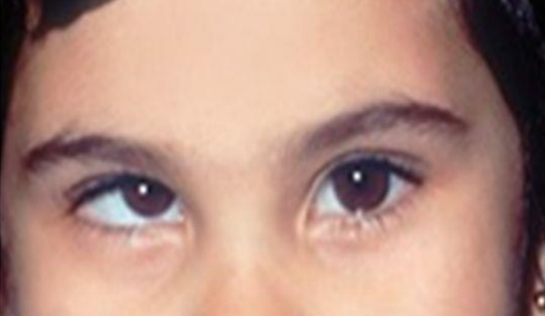

1. What pain characteristics are associated with type one trigeminal neuralgia?
2. Stabbing pain
3. Constant aching
4. Pain at night
5. Sudden, severe, shock-like