**10. Special techniques in the examination of the liver. Examination of the gallbladder.**

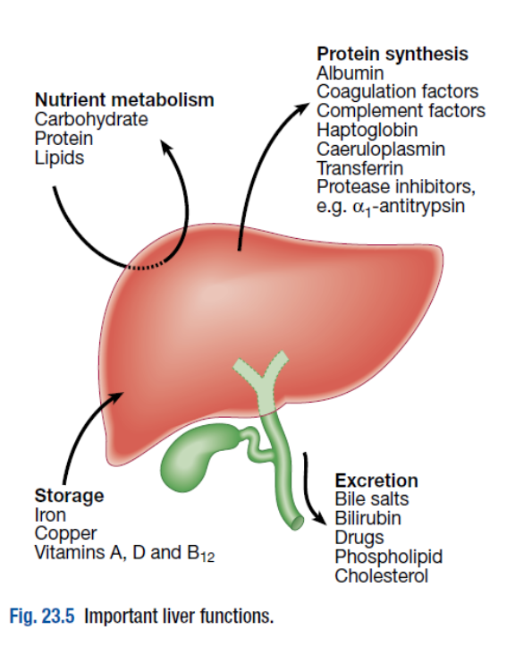**Special techniques in the examination of the liver.**

Davidson's Principles and Practice of Medicine 21st Ed

Liver disease may not cause any symptoms at first or the symptoms may be nonspecific, like weakness or loss of energy. We have a two types for examination of the liver: **laboratory tests or liver function tests and non-laboratory tests .**

**Aims of investigations in patients with suspected liver disease are:**

* Detect hepatic abnormality
* Measure the severity of liver damage
* Detect the pattern of liver function test abnormality: hepatitic or obstructive/cholestatic
* Identify the specific cause
* Investigate possible complications

**Laborotory test or Liver function tests:**

Liver function tests (LFTs) include the measurement of serum bilirubin, aminotransferases, alkaline phosphatase, gamma-glutamyl transferase ,albumin and prothrombin time. These provide biochemical markers of liver cell damage. However abnormalities on LFTs are often non-specific. The patterns are very helpful in directing further investigations.

* **Bilirubin and albumin**

The degree of elevation of bilirubin reflects the degree of liver damage. A raised bilirubin often occurs earlier in the natural history of biliary disease (e.g. primary biliary cirrhosis) than in disease of the liver parenchyma (e.g. cirrhosis) where the hepatocytes are primarily involved. Serum albumin levels are often reduced in patients with liver disease. Thre reduced level is caused by reduction int the synthesis and the distribution of albumin.

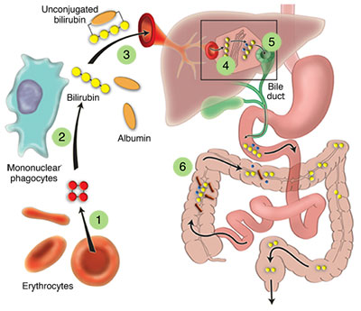

1. Heme, the substrate of bilirubin, is derived from red blood cells that have died.
2. Heme is degraded to biliverdin by heme oxygenase in the mononuclear phagocytes.
3. Biliverdin is subsequently reduced to bilirubin by biliverdin reductase.
4. Circulating bilirubin (insoluble) is bound to albumin and subsequently taken up by the hepatocytes.
5. To make it soluble, bilirubin undergoes conjugation, a reaction catalyzed by [bilirubin UDP](https://www.hepatitis.va.gov/provider/courses/livertests/livertests-glossary.asp#S1.9X)[glucuronyl transferase (UDPG)](https://www.hepatitis.va.gov/provider/courses/livertests/livertests-glossary.asp#S1.10X).
6. Conjugated bilirubin (soluble) is excreted into bile and reaches the bowel.
7. Bilirubin glucuronides are deconjugated by colonic bacteria and eliminated in the feces

**Bilirubin metabolism**

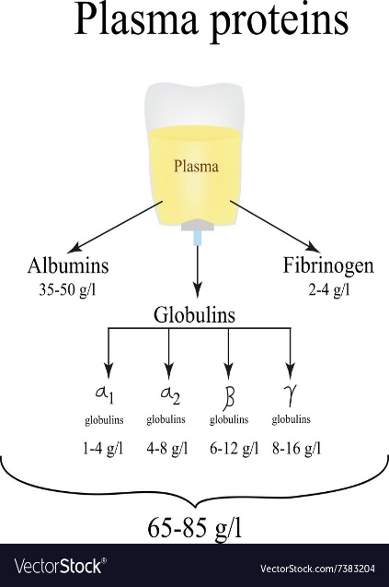

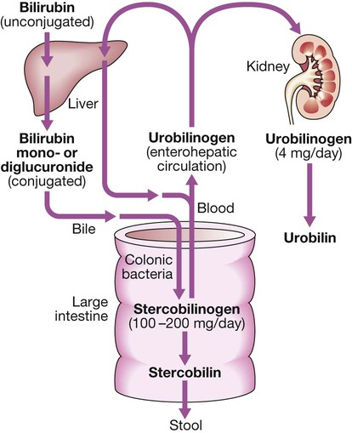

Davidson's Principles and Practice of Medicine 21st Ed

* **Alanine aminotransferase (ALT) and aspartate aminotransferase (AST)**

ALT and AST normally transfer the amino group from an amino acid—alanine in the case of ALT and aspartate in the case of AST—to a ketoacid, producing pyruvate and oxalo-acetate respectively. Both ALT and AST are found in the cytoplasm of the hepatocyte; AST can also be found in the hepatocyte mitochondria. Although both enzymes are widely distributed, expression of ALT outside the liver is relatively low and therefore this enzyme is considered more specific for hepatocellular damage. Large increases of aminotransferase activity indicates hepatocellular damage, and this pattern of LFT abnormality is known as ‘hepatitic’.

* **Alkaline phosphatase (ALP)**

ALP enzymes in the liver are located in cell membranes of the hepatic sinusoids and the biliary canaliculi. Accordingly, levels rise with intrahepatic and extrahepatic biliary obstruction and with sinusoidal obstruction, as occurs in infiltrative liver disease.

* **Gamma-glutamyl transferase (GGT)**

GGTis a microsomal enzyme found in many cells and tissues of the body. The highest concentrations are found in the liver, where it is produced by hepatocytes and by the epithelium lining small bile ducts. The function of GGT is to transfer glutamyl groups from gamma-glutamyl peptides to other peptides and amino acids. The pattern of a modest increase in aminotransferase activity and large increases in ALP and GGT activity favours biliary obstruction and is commonly described as ‘cholestatic’ or ‘obstructive’. Isolated elevation of the serum GGT is relatively common, and may occur during ingestion of microsomal enzyme-inducing drugs or. alcohol.

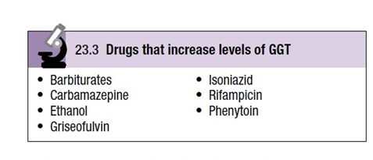

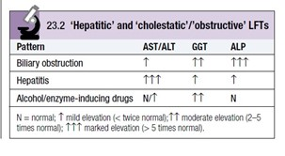

Davidson's Principles and Practice of Medicine 21st Ed

* **Routine haematology**

These investigations are often abnormal in patients with liver disease and can give a clue to the underlying diagnosis:

* A normochromic normocytic anaemia may reflect recent gastrointestinal haemorrhage, whereas chronic blood loss is characterised by a hypochromic microcytic anaemia secondary to iron deficiency
* Leucopenia may complicate portal hypertension and hypersplenism
* Leucocytosis may occur with cholangitis, alcoholic hepatitis and hepatic abscesses. Atypical lymphocytes are seen in infectious mononucleosis, which may be complicated by an acute hepatitis.
* Thrombocytopenia is common with cirrhosis and is due to reduced platelet production , and increased breakdown because of hypersplenism. Thrombopoietin, required for platelet production, is produced in the liver and levels fall with worsening liver function. Thus platelet levels are usually lower than white cells and haemoglobin in the presence of hypersplenism in patients with cirrhosis.
* Thrombocytosis is unusual in patients with liver disease but may occur in those with active gastrointestinal haemorrhage and, rarely, in association with hepatocellular carcinoma.
* **Coagulation tests**

Tests of the coagulation system are often abnormal in patients with liver disease. An increased prothrombin time is evidence of severe liver damage in chronic liver disease. Vitamin K does not reverse this deficiency if it is due to liver disease, but will reverse the prothrombin time if due to vitamin K deficiency, as may occur with biliary obstruction due to non-absorption of fat-soluble vitamins.

* **Immunological tests**

A variety of immunological tests, often known as a‘chronic liver disease screen’ are available to evaluate the aetiology of hepatic disease

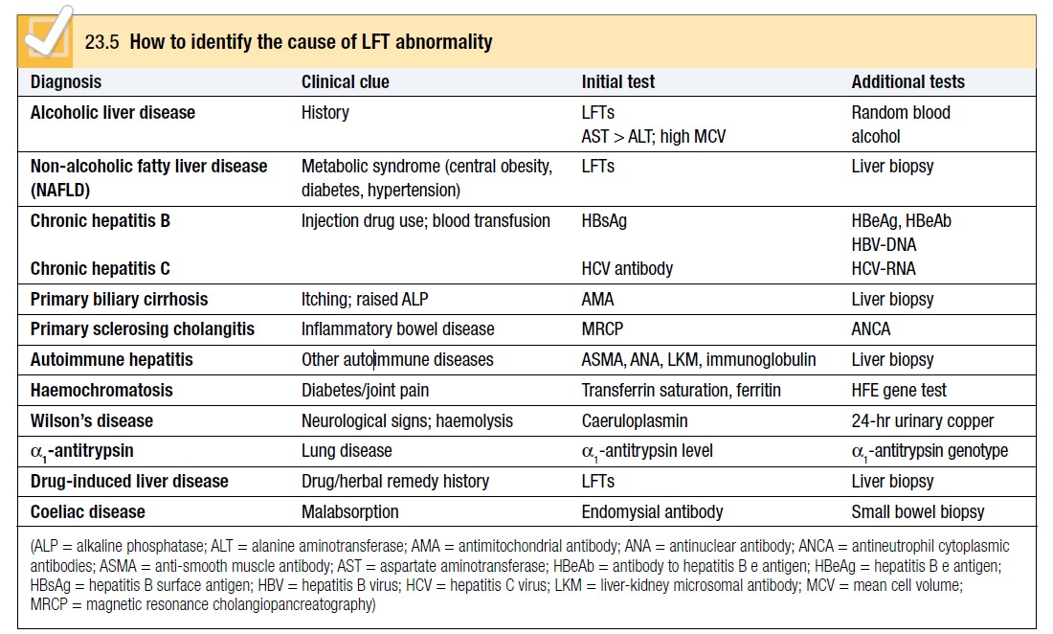

Davidson's Principles and Practice of Medicine 21st Ed

**Non-laboratory tests**may include:

* **Ultrasound**

Is a non-invasive technique and also a very useful one in the initial assessment of patients with liver disease .Ultrasound is good for the identification of splenomegaly .

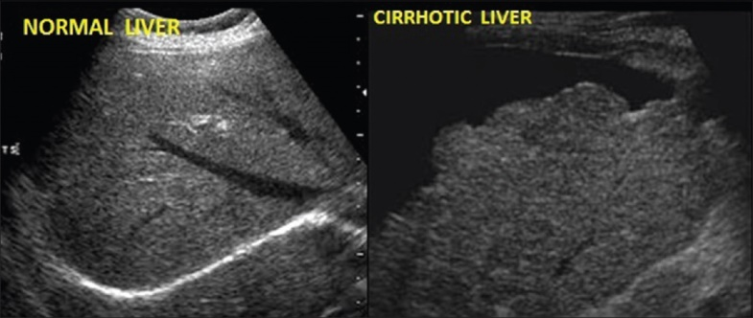

-Colour Doppler ultrasound allows blood flow in the hepatic artery, portal vein and hepatic veins to be investigated.

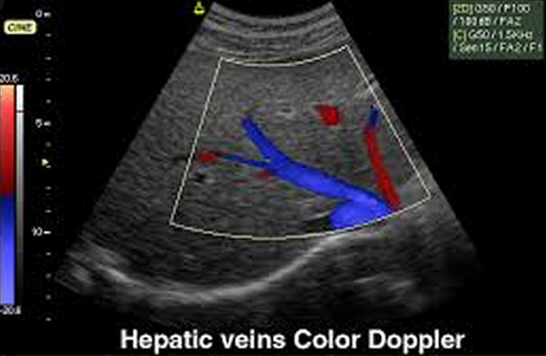

- Endoscopic and laparoscopic ultrasound provide high resolution images of the pancreas, biliary tree and liver.

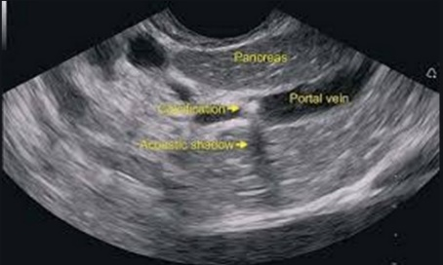

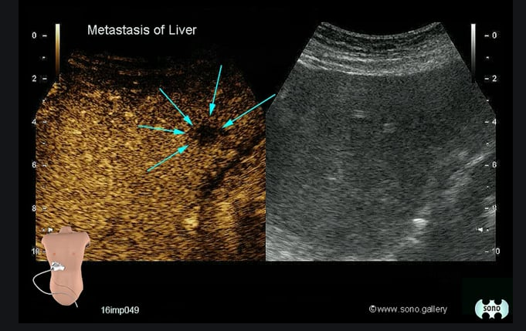**-**Abdominal contrast-enhanced ultrasound**, also known as CEUS**, is an ultrasound examination that uses gas-filled microbubbles to better visualize organs and blood vessels within the abdomen and pelvis, including the liver, spleen, kidneys, pancreas, bowel and bladder.

With contrast without contrast

* **Liver biopsy**

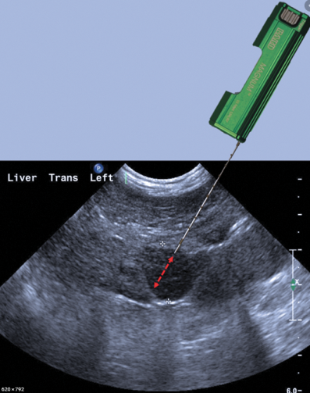An ultrasound-guided liver biopsy can confirm the severity of liver damage and provide aetiological information; it is performed percutaneously with a Trucut or Menghini needle, usually through an intercostal space, under local anaesthesia. Histological assessment of liver biopsy tissue is enhanced by discussion between clinicians and pathologists. The liver disorders can be broadly classified histologically into fatty liver (steatosis), hepatitis and cirrhosis.

* **Computed tomography**

Computed tomography can be used for the same purpose as ultrasound but detects smaller focal lesions in the liver, especially when combined with contrast injection.

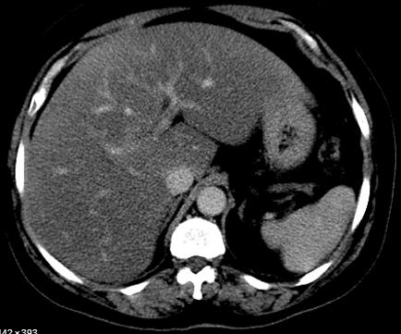

* **Мagnetic resonance imaging**

Magnetic resonance imaging (MRI) can also be used to localise and confirm the aetiology of focal liver lesions, particularly primary and secondary tumours.

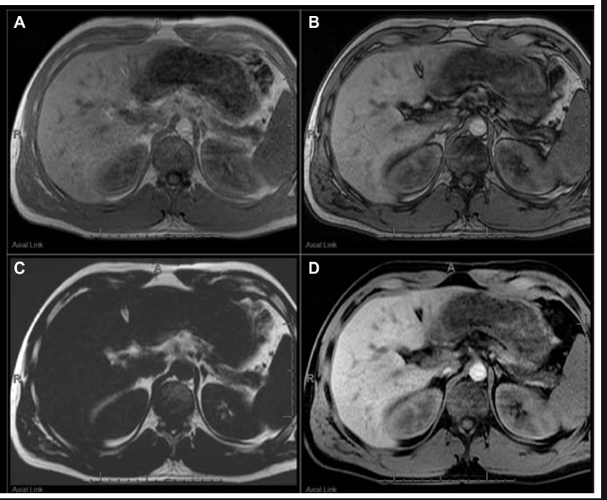

* **Cholangiography**

Cholangiography can be undertaken by magnetic resonance.

* Cholangiopancreatography endoscopy

Cholangiopancreatography endoscopy (endoscopic retrograde cholangiopancreatography, ERCP) or the percutaneous approach (percutaneous transhepatic cholangiography, PTC). The latter does not allow the ampulla of Vater or pancreatic duct to be visualised.

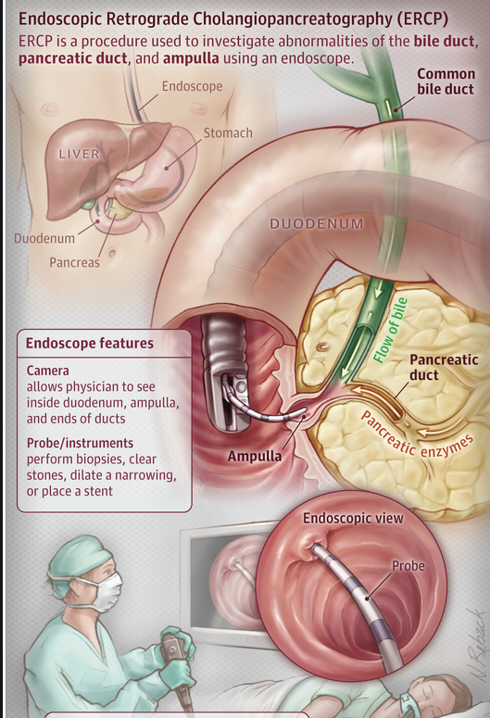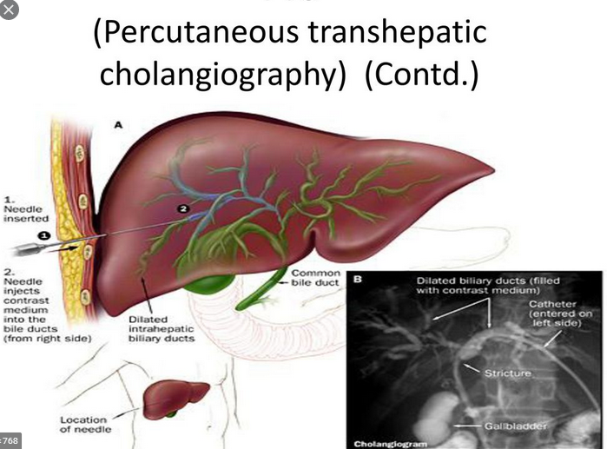

MRCP is as good as ERCP at providing images of the biliary tree but has fewer complications and is the diagnostic test of choice. Both endoscopic and percutaneous approaches allow therapeutic interventions such as the insertion of biliary stents across malignant bile duct strictures. The percutaneous approach is only used if it is not possible to access the bile duct endoscopically.

**2.Examination of the gallbladder**

We start with the medical history, physical exam,laboratory tests and non- laboratory tests

**1.Medical history**

Potential questions could be:

* **Are you experiencing abdominal pain, and if so where?** Pain in the upper right or upper middle side of the abdomen is suggestive of a gallbladder problem.
* **Is the abdominal pain associated with eating?** With gallstones, an intense, dull pain could occur in one or more hours after eating fatty foods and last at least thirty minutes.
* **Have you ever experienced this abdominal pain before?** Episodes of gallstone pain generally get worse over time and may lead to complications like an infection of the bile ducts or inflammation of the pancreas.
* **Are you experiencing any other symptoms besides pain, like fevers, nausea, vomiting, or weight loss?**These associated symptoms can help a doctor pinpoint whether gallbladder disease and other possible complications are present.

**2. Physical exam**

**-Inspection for:**

* Jaundice:

-yellow appearance of the skin, sclerae and mucous membranes

-increased bilirubin concentration in the body fluids

-detectable clinically when the plasma bilirubin exceeds 50 μmol/l (∼3 mg/dl)

-recognition is often dependent on the ambient light available

* Inspection of the abdomenshould be done with the patient in lying position for any abnormalities, scars and scratches.

**-Palpation**

The gallbladder is palpated the same way as the liver. The normal gallbladder cannot be felt. When it is distended, however, it forms an important sign and may be palpated as a firm, smooth, or globular swelling with distinct borders, just lateral to the edge of the rectus abdominis near the tip of the ninth costal cartilage. It moves with respiration.When the liver is enlarged or the gallbladder grossly distended, the latter may be felt not in the hypochondrium but in the right lumbar or even as low down as the right iliac region.

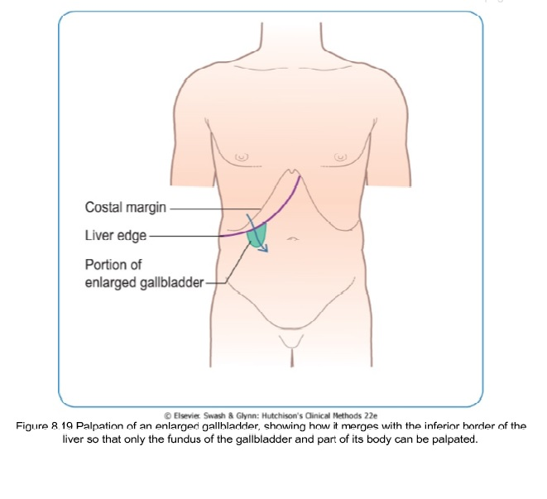

**Courvoisier's Law**

This states that in the presence of jaundice a palpable gallbladder makes gallstone obstruction of the common bile duct an unlikely cause.

**"Murphy's sign**

Ask the patient to breathe in deeply, and palpate for the gallbladder in the normal way; at the height of inspiration the breathing stops with a gasp as the mass is felt. . If a person experiences significant pain during this test (called a positive "Murphy sign") This sign is typical for acute cholecystitis. The sign is not found in chronic cholecystitis or uncomplicated cases of gallstones.

* **Percussion**
* **Auscultation**

**3. Laboratory tests**

We can make a biochemical test of the liver function.

E.g. Gallstones causing obstruction of the common bile duct will result in elevations of hepatic transaminases and alkaline phosphatase

**4. Non- Laboratory tests**

**-Ultrasonography:**

**e.g.** Ultrasound may also indicate distal obstruction by the finding of dilated intrahepatic or extrahepatic bile ducts. This test is less useful for excluding gallstones obstructing the common bile duct.

**-CEUS:**

**-CT scan:**

**e.g.** Their principle use is detection of the complications of gallstones such as pericholecystic fluid, gas in the gallbladder wall, gallbladder perforations, and abscesses. These noninvasive tests may help determine which patients will require urgent surgical intervention

**-MRI and MRCP**

Magnetic resonance cholangiopancreatography (MRCP) is a relatively new application that utilizes MRI imaging with special software. It is capable of producing images similar to ERCP without the accompanying risks of sedation, pancreatitis, or perforation. MRCP is helpful in assessing biliary obstruction and pancreatic ductal anatomy. It has been shown to be effective in detecting gallstones and to evaluate the gallbladder for the presence of cholecystitis.