9. Palpation of the liver

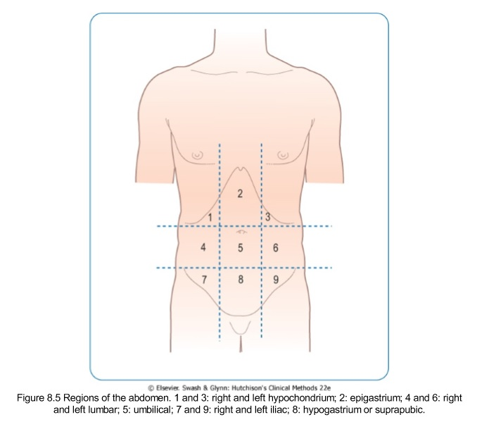The abdominal muscles should be relaxed to enhance the palpation. Stand at the parient`s right side. Palpation is performed to determine liver shape, surface, consistency and tenderness.

**Methods for palpation of the liver. Technique. Normal and pathological findings.**

* Single – handed palpation

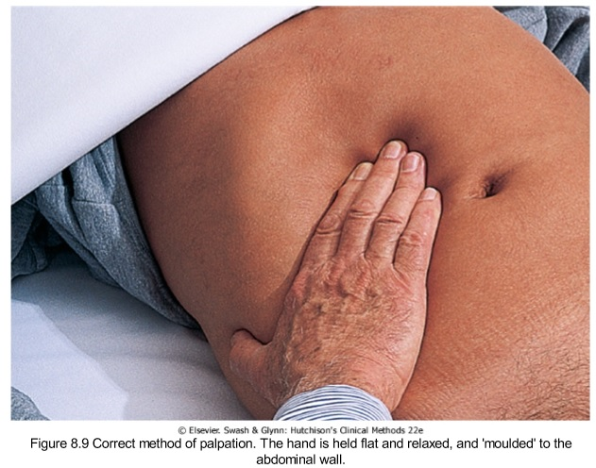The right hand of the examiner is placed below the level of the percussed dullness of the inferior liver margin in the midclavicular line parallel to the rectus muscle. This is the best point to feel the liver.

* Bimanual palpation

Have your left hand placed behind the patient parallel to and supporting the right 11th and 12th ribs and nearby soft tissues below. Place your right hand on the patient’s right abdomen lateral to the rectus muscle, with your fingertips far below the lower border of liver dullness. Having done those two things you should ask the patient to take a deep breath. You should try to feel the edge of the liver as it meets your fingertips. If you do feel it, than light the pressure of the hand you are palpating with so that the liver can slip under your finger pads and you can feel its anterior surface.

**If palpable at all, the edge of a normal liver is soft, sharp, and regular, it`s surface smooth. The normal liver may be slightly tender.** On inspiration, the liver is palpable about 3 cm below the right costal margin in the midclavicular line.



* **The “hooking technique”**

The hooking technique is especially helpful when the patient is obese. Position to the right of the pateint’s chest. Have both hands on the right abdomen below the border of liver dullness. Press in with your finger pads up toward the costal margin. Ask the patient to take a deep breat. The liver edge shown on the next picture is palapable with fingerpads of both hands.

