
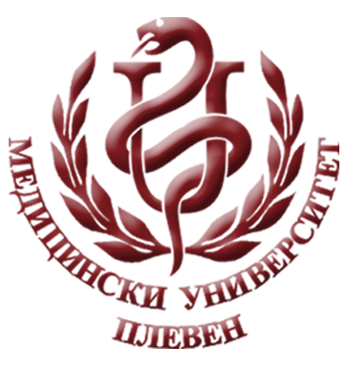
MEDICAL UNIVERSITY - PLEVEN
DISTANCE LEARNING CENTRE

Prof. Dr. Silviya Aleksandrova-Yankulovska, DSc

SOCIAL MEDICINE

lecture course

FOR E-LEARNING

FOR STUDENTS AT MEDICAL UNIVERSITY – PLEVEN

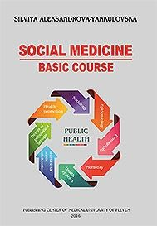

PLEVEN, 2020

