**Department of (Psychiatry and medical psychology)**

**practical exerciseS – THESES**

**FOR E- LEARNING IN (medical psychology)**

**ENGLISH MEDIUM COURSE OF TRAINING**

**SPECIALTY OF MEDICINE**

**academic degree: mASTER**

**Professional qualification: Doctor of Medicine**

**prepared by (Assis. Prof. Elisaveta Krasteva, MD)**

PRACTICAL EXERSICES – THESES

**4. Stress – definitions and terms. Physical responses to stress. Stress and the immune system. Life events and stress. Stress as a person-environment interaction. Stress and health. Stress in medicine. Managing stress.**

**1. Introduction and definitions**

**1.1 What is stress?**

The term ‘stress’ means many things to many different people. A layperson may define stress in terms of pressure, tension, unpleasant external forces or an emotional response. Psychologists have defined stress in a variety of different ways. Contemporary definitions of stress regard the external environmental stress as a stressor (e.g. problems at work), the response to the stressor as stress or distress (e.g. the feeling of tension), and the concept of stress as something that involves biochemical, physiological, behavioural and psychological changes. Researchers have also differentiated between stress that is harmful and damaging (distress) and stress that is positive and beneficial (eustress). In addition, researchers differentiate between acute stress, such as an exam or having to give a public talk, and chronic stress, such as job stress and poverty. The most commonly used definition of stress was developed by Lazarus and Launier (1978), who regarded stress as a transaction between people and the environment and described stress in terms of ‘person–environment fit’. If a person is faced with a potentially difficult stressor such as an exam or having to give a public talk, the degree of stress they experience is determined first by their appraisal of the event (‘is it stressful?’) and second by their appraisal of their own personal resources (‘will I cope?). A good person–environment fit results in no or low stress and a poor fit results in higher stress.

**Stress has many components but the most important distinction is between:**

**1. Stressor - event that triggers a stress response**

**Based on their origin stressors are subdivided to:**

**• External**

**• Internal**

**Based on their type and duration stressors are sub- classified to:**

**• Acute**

**• Chronic**

**• Daily hassles**

**• Traumatic stressors**

**• Role strain**

**2. Stress responses - the various ways to respond to a stressor. They are subdivided into:**

**• Cognitive**

**• Affective**

**• Behavioral**

**• Physiological**

**2. Physical responses to stress.**

**2.1 Fight-or-flight response to stress involves:**

**•** the sympathetic branch of the autonomic nervous system as a fast, first wave response.

• the endocrine pathways of the hypothalamic-pituitary-adrenal (HPA) axis as a slower, second wave response.

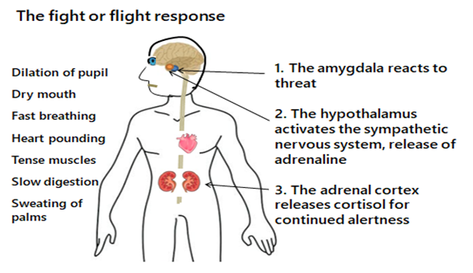

**2.2. Selye’s general adaptation syndrome**

Selye’s general adaptation syndrome (GAS) was developed in 1956 and described three stages in the stress process (Selye 1956). The initial stage was called the ‘alarm’ stage, which described an increase in activity, and occurred as soon as the individual was exposed to a stressful situation. The second stage was called ‘resistance’, which involved coping and attempts to reverse the effects of the alarm stage. The third stage was called ‘exhaustion’, which was reached when the individual had been repeatedly exposed to the stressful situation and was incapable of showing further resistance.

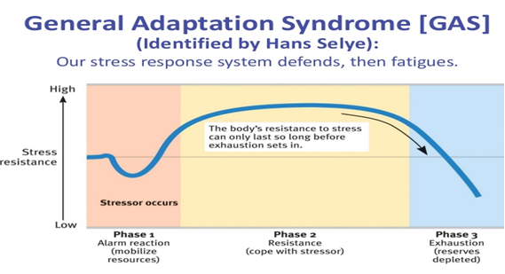

Physiological responses to stress will differ according to:

• Circumstances

• Individual differences

• The group involved

**3. Stress and immune system**

Stress will have various effects on the immune system, depending on the demands of the situation.

• The sympathetic nervous system increases immune system activity, particularly large granular lymphocyte activity such as NK-cells (natural killers cells).

• The HPA axis suppresses some immune activity through the production of cortisol, which has an anti-inflammatory effect and reduces both the number of white blood cells (WBC) and the release of cytokines.

Different type of stressful events invoke different immune responses. Short stressors lead to an acute immune response such as the one described above to provide an immediate defense against injuries and the broad risk of infection. This response is rapid and the immune system will quickly return to baseline levels. Stressors lasting several days lead to increase in cytokine production and thus the body is more able to co-ordinate responses against infections. Chronically stressful events will have a negative impact on almost all aspects of immune functioning, with poorer immune function overall. This makes a person more likely to get ill, particularly if they are already vulnerable (e.g. older people) or have a pre-existing disease.

**4. Life events and stress.**

Life events are usually measured with a checklist of different types of stressful events (e.g. divorce, bereavement, marriage, or financial problems).

Advantages:

• Distinguishes the stressor from the stress

• Provides an objective measure of stress response.

Disadvantages:

• Fails to account for individual differences in events that are perceived as stressful

• Measurement of stress by checklists is likely to be affected by recall biases - people who are ill are much more likely to search for a cause of their illness and attribute it to stress in comparison to those that are healthy.

A more precise measure of personal stress can be determined by using a variety of instruments that have been designed to help measure individual stress levels. The first of these is called the Perceived Stress Scale.

The Perceived Stress Scale

The Perceived Stress Scale (PSS) is a classic stress assessment instrument. The tool, while originally developed in 1983, remains a popular choice for helping us understand how different situations affect our feelings and our perceived stress. The questions in this scale ask about your feelings and thoughts during the last month. In each case, you will be asked to indicate how often you felt or thought a certain way. Although some of the questions are similar, there are differences between them and you should treat each one as a separate question. The best approach is to answer fairly quickly. That is, don’t try to count up the number of times you felt a particular way; rather indicate the alternative that seems like a reasonable estimate.

**l. In the last month, how often have you been upset because of something that happened unexpectedly?**

**2. In the last month, how often have you felt that you were unable to control the important things in your life?**

**3. In the last month, how often have you felt nervous and stressed?**

**4. In the last month, how often have you felt confident about your ability to handle**

**your personal problems?**

**5. In the last month, how often have you felt that things were going your way?**

**6. In the last month, how often have you found that you could not cope with all the things that you had to do?**

**7. In the last month, how often have you been able to control irritations in your life?**

**8. In the last month, how often have you felt that you were on top of things?**

**9. In the last month, how often have you been angered because of things that happened that were outside of your control?**

**10. In the last month, how often have you felt difficulties were piling up so high that**

**you could not overcome them?**

Individual scores on the PSS can range from 0 to 40 with higher scores indicating higher perceived stress.

• Scores ranging from 0-13 would be considered low stress.

• Scores ranging from 14-26 would be considered moderate stress.

• Scores ranging from 27-40 would be considered high perceived stress.

The Perceived Stress Scale is interesting and important because your perception of what is happening in your life is most important. Consider the idea that two individuals could have the exact same events and experiences in their lives for the past month. Depending on their perception, total score could put one of those individuals in the low stress category and the total score could put the second person in the high stress category.

**5. Stress as a person-environment interaction.**

Interactional explanations of stress posit that the response to stress depends on the interaction between a person and his/her environment - stress occurs when a person appraises the demands of a situation as being greater than their ability to cope with them.*

Appraisal processes are central and explain the great variation in how people respond to stressful circumstances. Those who apprise an event as challenging will have smaller cortisol responses than those who apprise it as stressful.

Three processes of appraisal are outlined:

• Primary appraisal: the demands of the situation are evaluated as benign, challenging, or stressful/threatening.

• Secondary appraisal: a person evaluates their resources and the ability to cope.

• Reappraisal: a person reconsiders the situation once they have tried to cope with it. It may be seen as less or more stressful than originally thought, depending on the effect of their coping responses.

**6. Stress and health**

Evidence show that stress increases the morbidity of:

• Episodes of infectious illnesses (like colds)

• Cardiovascular disease

• Wound healing (slower it)

Additionally, stress worsens auto-immune conditions such as:

• Asthma

• Rheumatoid arthritis

• Inflammatory bowel disease

• HIV/AIDS

It is well known that chronic or severe stress can lead to a number of mental health problems including:

• Anxiety

• Depression

• Stress burnout

• Post-traumatic brain disorder (PTSD)

*Vulnerability-stress model*

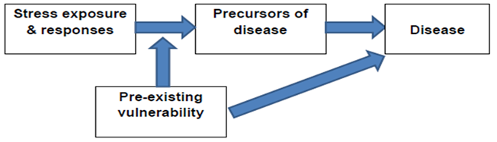

Moderators of the effect of stress on health include:

• Personality

• Coping methods used by the particular individual

• Available social support

• Practicing of physical exercise

**7. Stress in medicine**

Medicine is an inherently stressful profession: it involves dealing with health crises and making life and death decisions. As already mentioned, stress is associated with a range of negative psychological states including anxiety, depression, PTSD and burnout.

Stress burnout is experienced by approximately 20% of adults and has three main symptoms:

• Emotional exhaustion

• Depersonalization

• Reduced personal accomplishment

Burnout leads to high job dissatisfaction, absenteeism, and staff turnover. Symptoms of exhaustion are associated with other physical symptoms (headaches, gastrointestinal disorders, hypertension, colds or flu, sleep disturbances etc.)

**8. Managing stress**

There are six main approaches to stress management:

• Relaxation

• Physical fitness

• Cognitive restructuring

• Meditation

• Assertiveness training

• Stress inoculation