**MEDICALUNIVERSITY - PLEVEN**

**DISTANCE LEARNING CENTRE**

**Assoc. Prof. Gena Grancharova MD, PhD**

⚫Medical statistics⚫

**FOR E-LEARNING**

**FOR STUDENTS AT MEDICAL UNIVERSITY–PLEVEN**

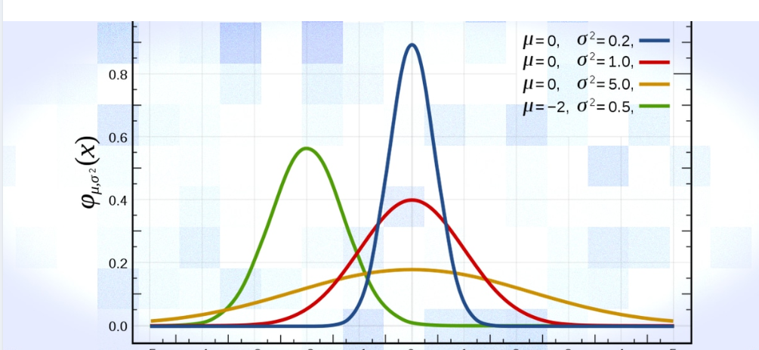

PLEVEN, 2019